**CHAPTER 4**

**RESULTS AND DISCUSSIONS**

In this chapter, it contains and discusses the project description, structures and capabilities of the developed system as well as the testing and evaluation results gathered by the proponents.

**PROJECT DESCRIPTION**

Nowadays, companies tend to promote their business in different ways such as building or creating their own website and planning new ideas to share and advertise through the use of social media for them to be recognized.

Web-Based Reservation and Billing System for Bataan White Corals Beach Resort is developed to manage and improve guest’s reservation and for walk-in reservations of the guest. The system includes a website that is available for viewing and to avail a reservation. Also, it helps ease the work of the staffs and admin.

**PROJECT STRUCTURES**

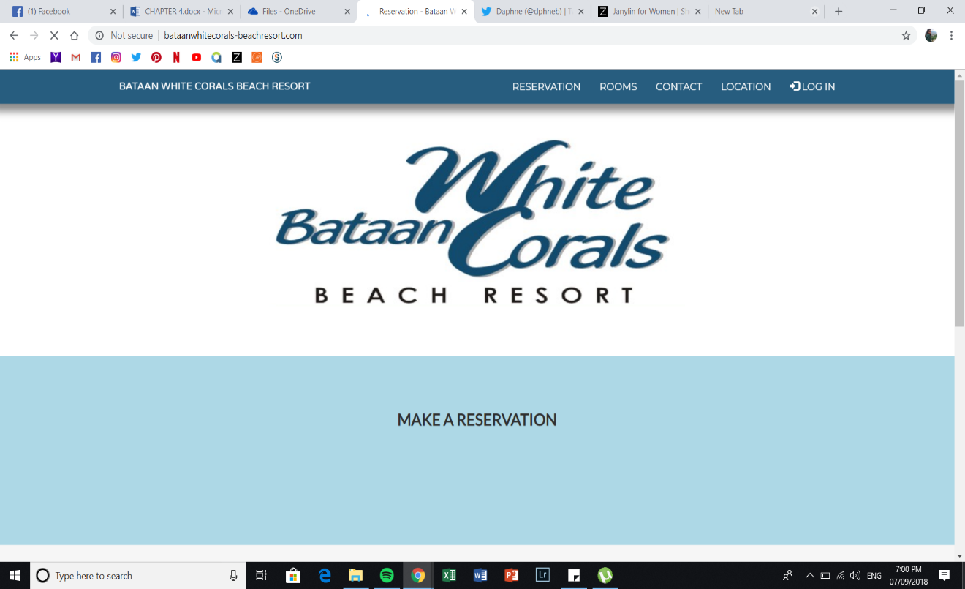

*Figure 63: Home Page*

It displays the home/main page of the website. Having a simple and easy navigation for the guest to view and explore the website.

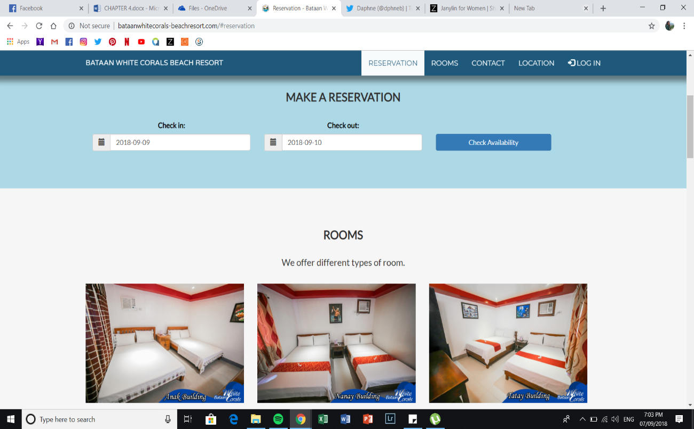

*Figure 64: Reservation*

It shows the reservation page where guests make or avail a reservation by checking the availability of the rooms.

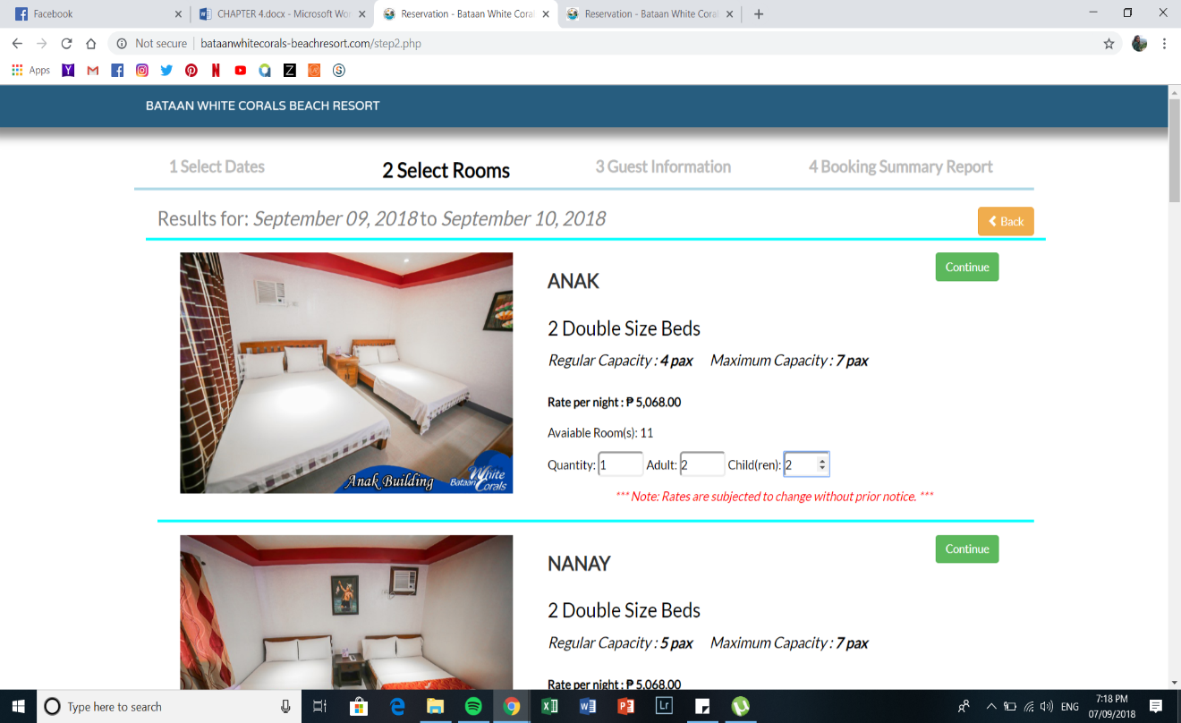

*Figure 65: Reservation (Select Rooms)*

Allows the guests to select their desired room. The guests can also specify the quantity of adults and children.

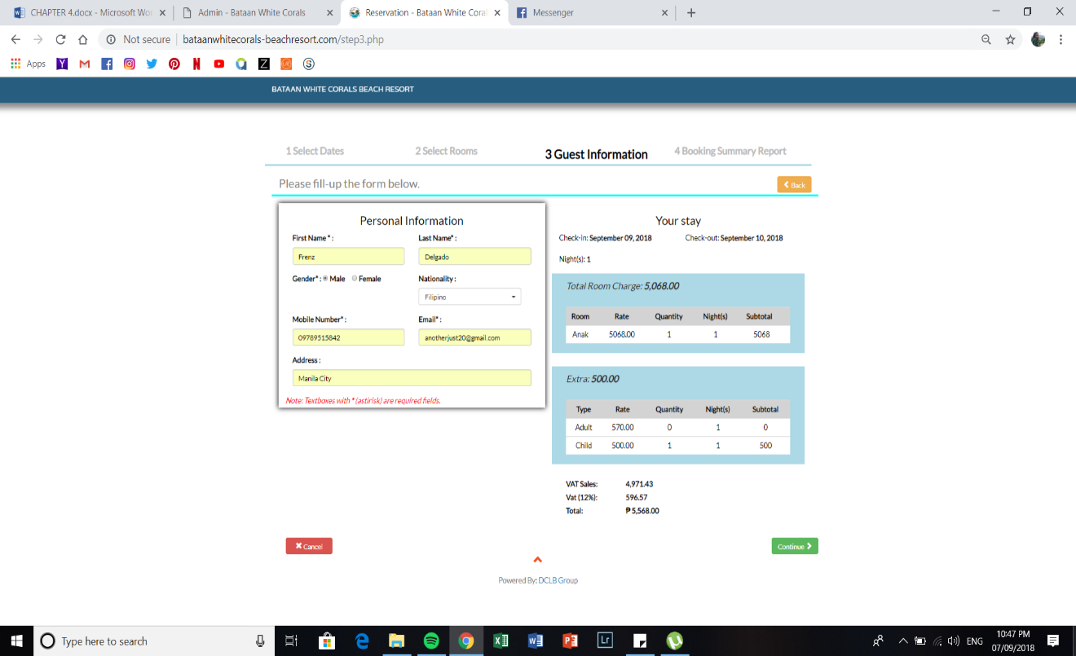

*Figure 66: Reservation (Guest Information)*

Displays the personal information of the guests together with the summary of their billing transaction.

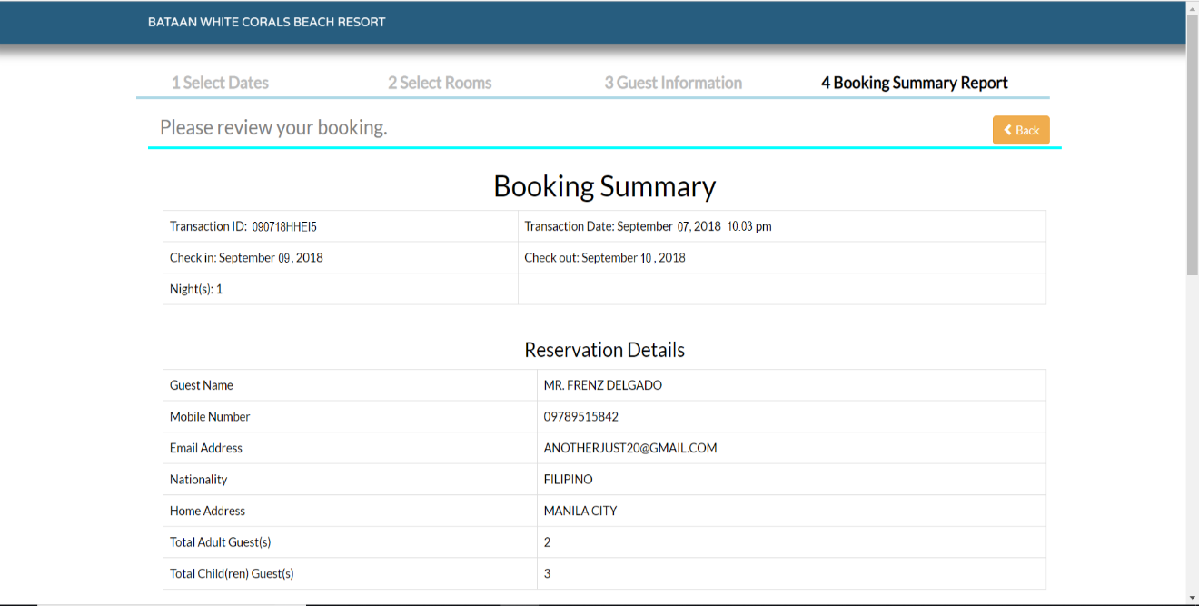

*Figure 67: Reservation (Booking Summary - Part 1)*

This figure shows the booking summary of the guest’s reservation together with the reservation details.

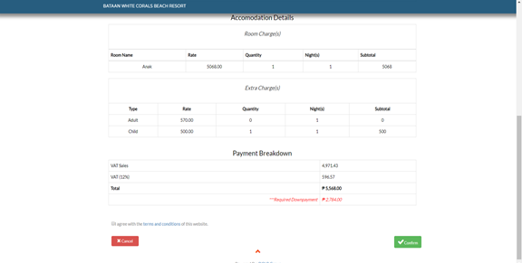

*Figure 68: Reservation (Booking Summary - Part 2)*

This figure shows the booking summary of the guest’s reservation and details together with the accommodation details and payment breakdown.

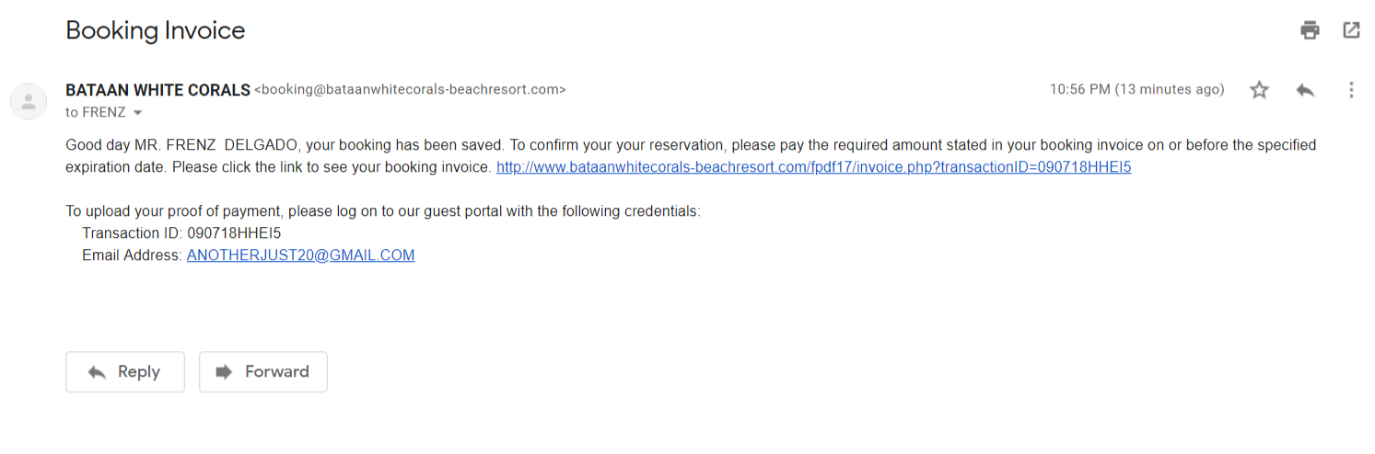*Figure 69: Email Confirmation*

It simply notifies the guest and update them regarding their reservation. It also includes the link to see their invoice which can be printed by the guest.

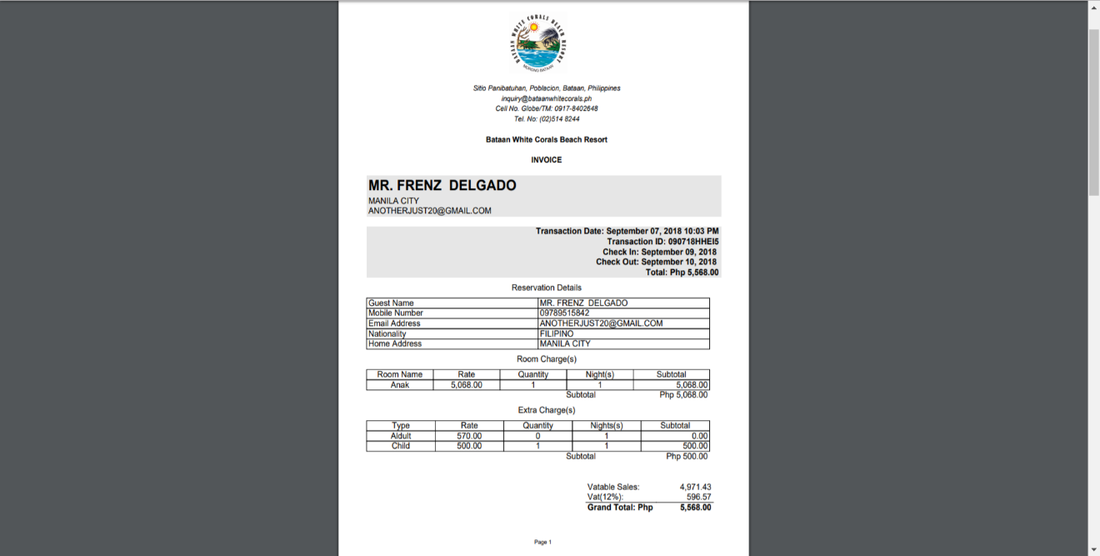

*Figure 70: Invoice*

This shows the invoice of the guest indicating their reservation details, room and extra charges, as well as the transaction date and time, check-in and out date, and the grand total of the guest’s reservation.

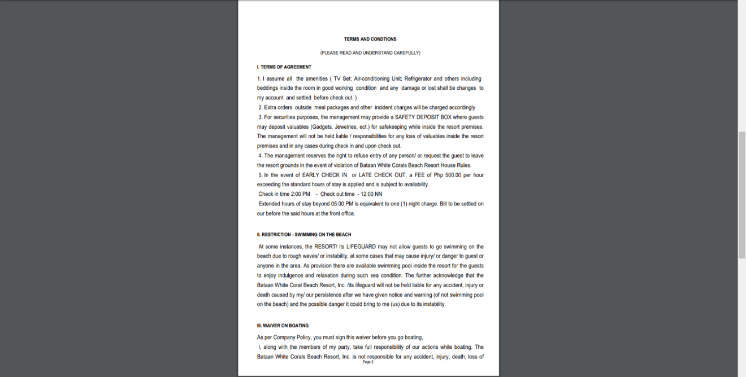

*Figure 71: Invoice (Terms and Conditions)*

This shows the terms and conditions of the resort which means the set of rules and guidelines that the guests must follow when they are inside the resort.

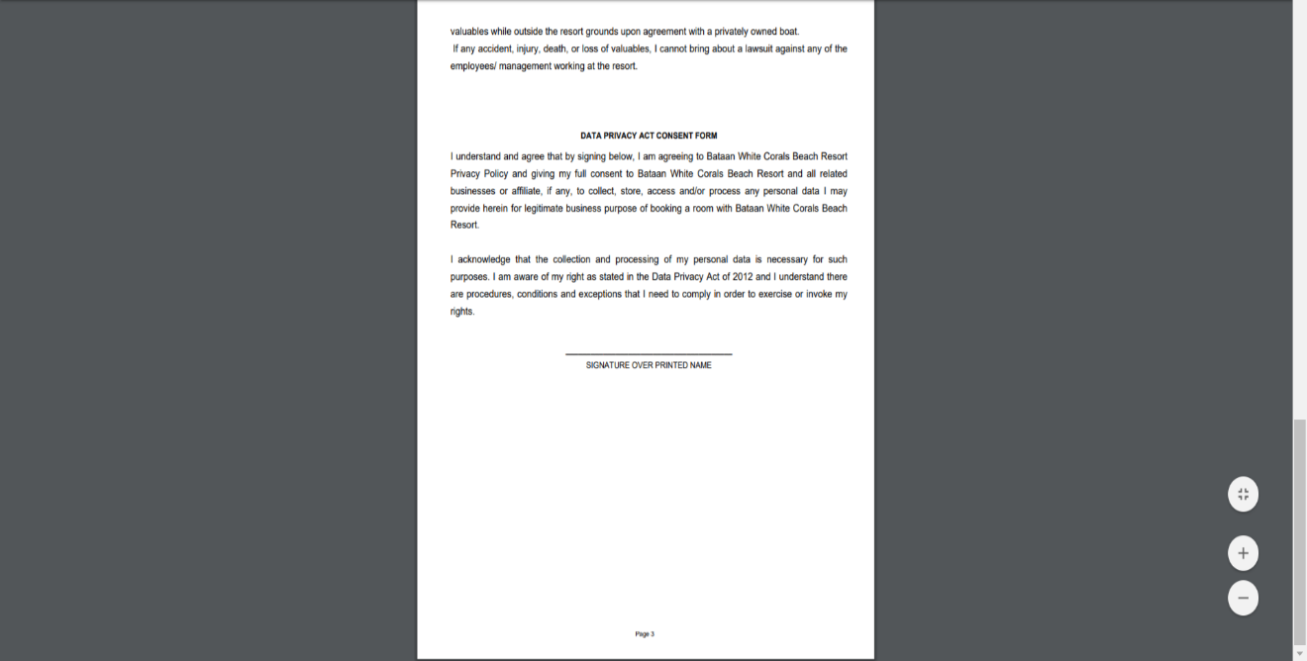

*Figure 72: Invoice (Data Privacy Consent Form)*

This shows the data privacy consent form which an agreement or contract between the guest and Bataan White Corals Beach Resort, to collect, store, and access the personal data of the guest.

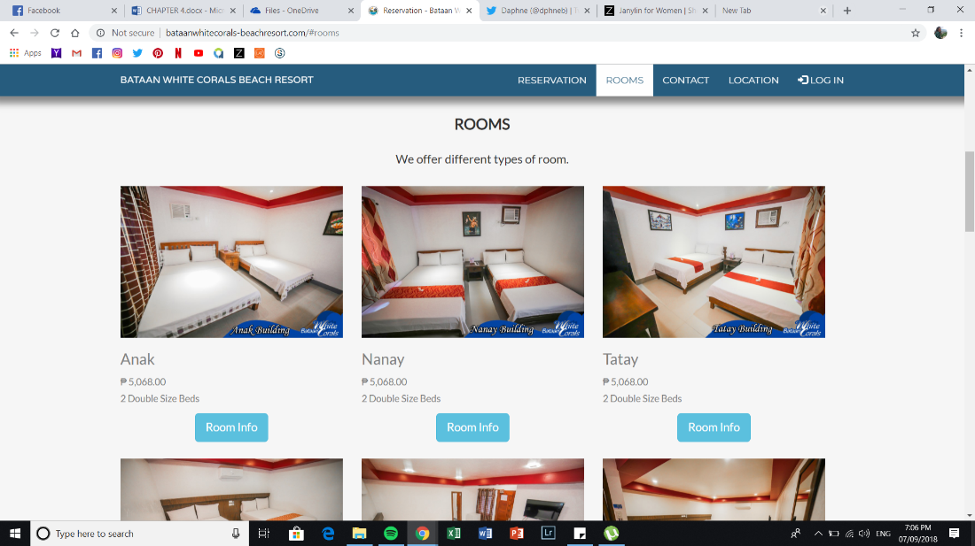

*Figure 73: Rooms*

It displays all the rooms that the resort offers as well as a brief information about a room.

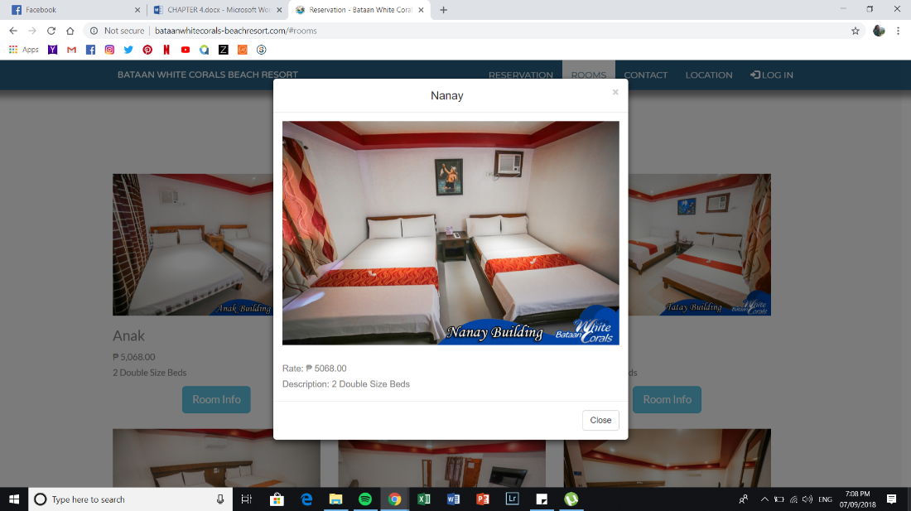

*Figure 74: Room Information*

Once the room info button is clicked, it will show the detailed information and description of the room.

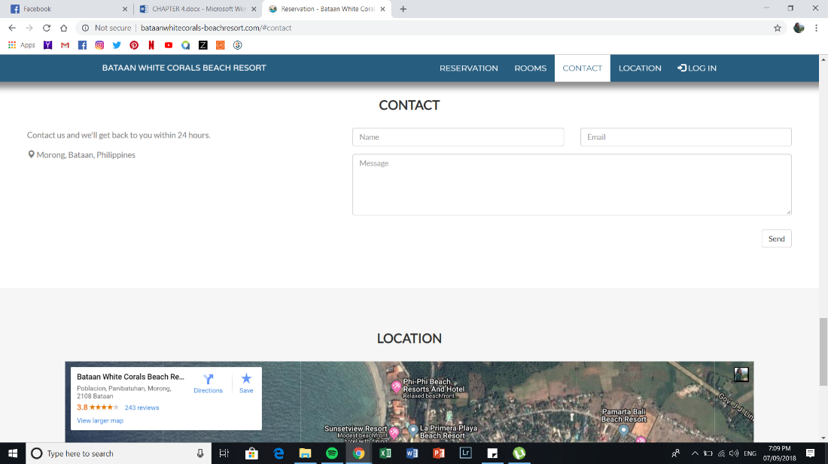

*Figure 75: Contact*

This figure shows the guest on how to contact and provide suggestions to the resort.

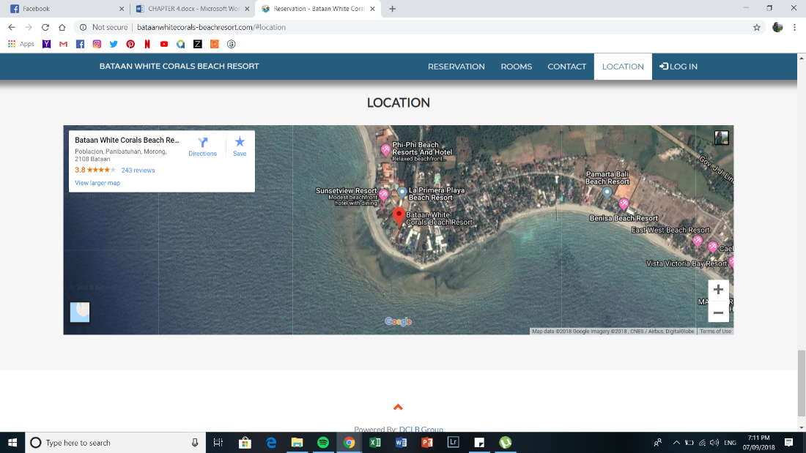

*Figure 76: Location*

It indicates where the resort is located. It also features a Google Maps widget

.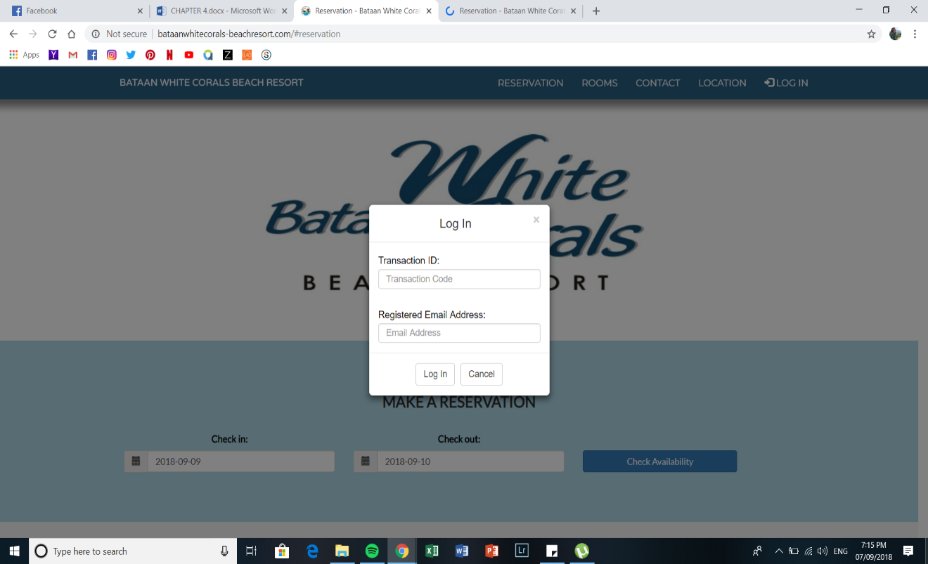

*Figure 77: Guest Log In*

This figure lets the guests to log-in to their respective account provided they give their transaction ID and registered e-mail address.

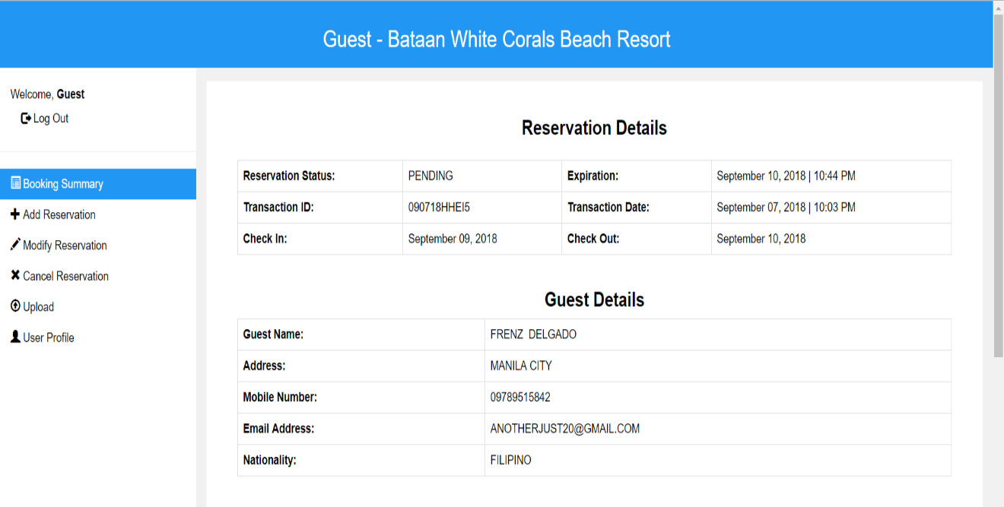*Figure 78: Guest Reservation Page (Booking Summary - Part 1)*

Shows the booking summary of the guest’s reservation together with the reservation and guest details such as the reservation status, expiration time and date, transaction id, check-in and out date. As well as the guest’s name, address, mobile number, email address, and nationality.

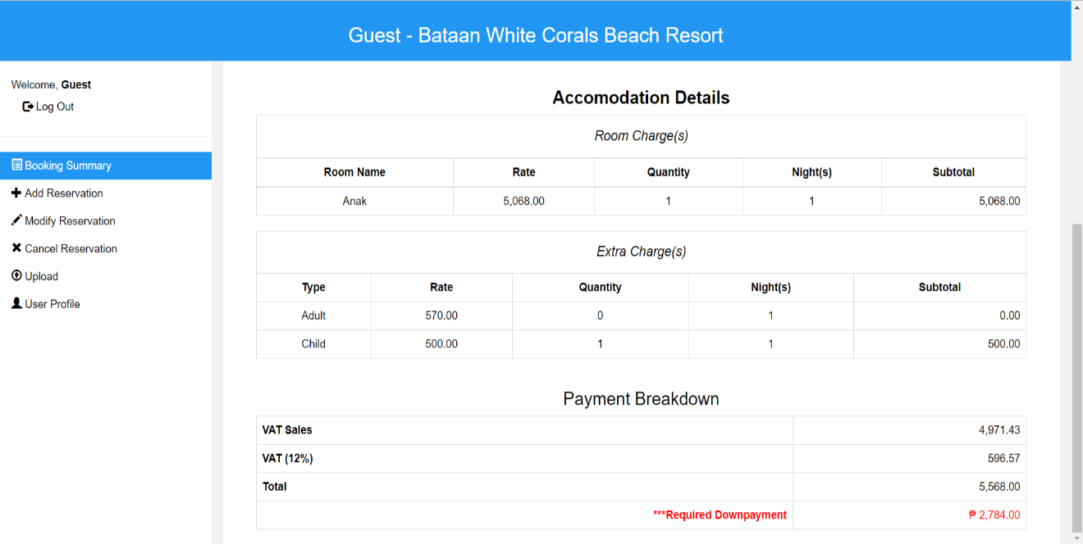

*Figure 79: Guest Reservation Page (Booking Summary - Part 2)*

Shows the booking summary of the guest’s reservation together with the accommodation details such as the room and extra charges, the payment breakdown of the reserved room indicating the vat sales, vat and total amount of the reservation.

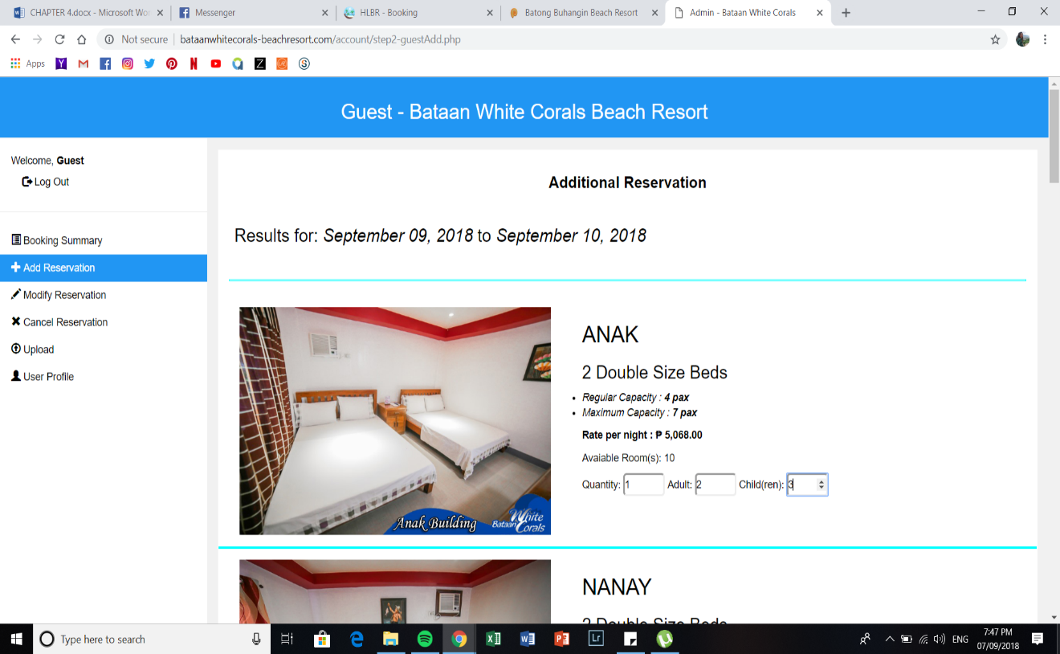

*Figure 80: Guest Reservation Page (Additional Reservation)*

Shows the page if the guests want to add another reservation and select their desired quantity of rooms, adult and children.

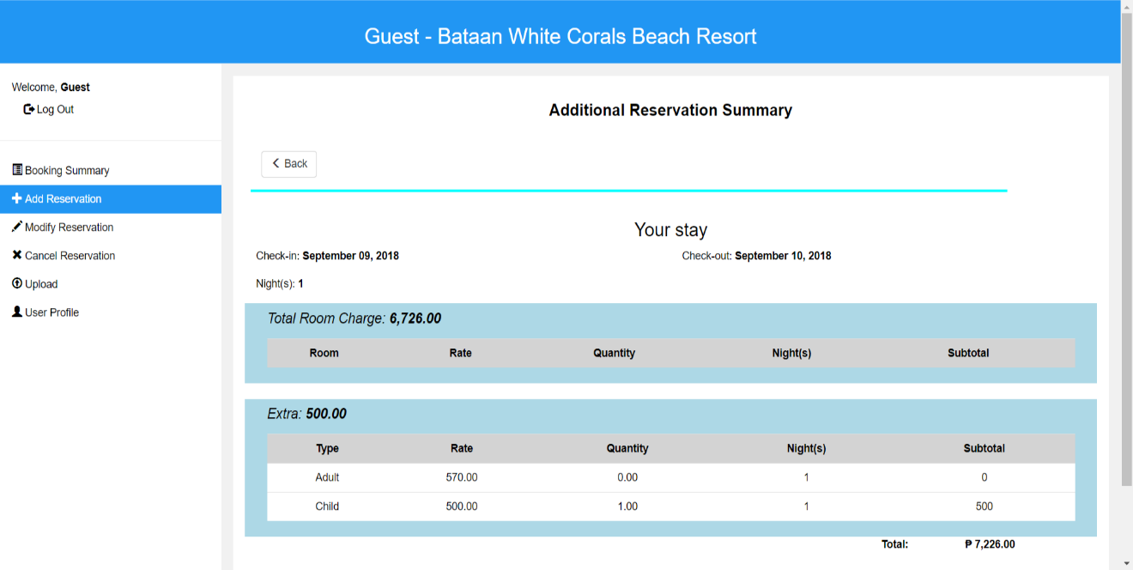*Figure 81: Guest Reservation Page (Additional Reservation Summary)*

It shows the additional reservation summary of the guest’s reservation together with the bill that the guest must pay.

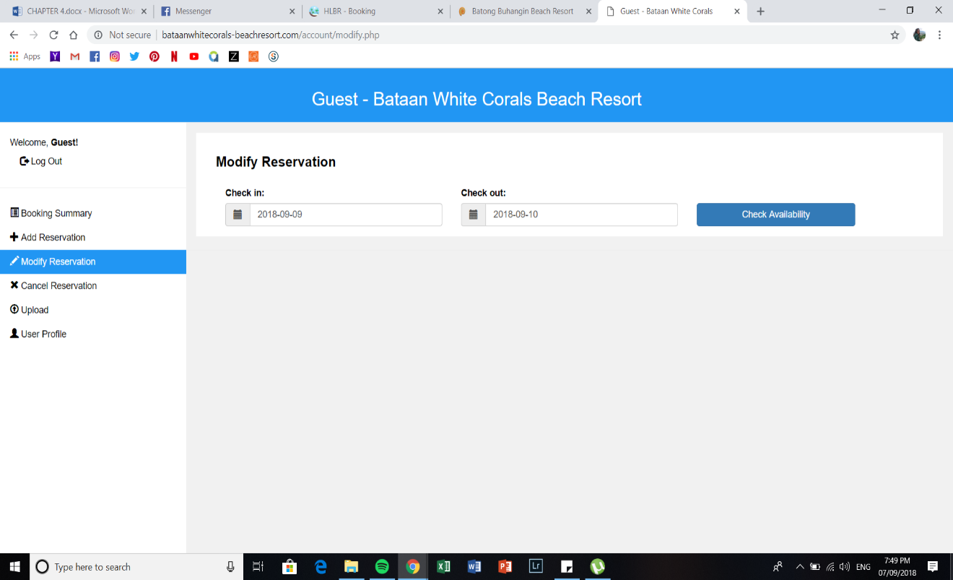*Figure 82: Guest Modify Reservation Page*

This module allows the user to modify his/her own reservation by selecting a check in and out date.

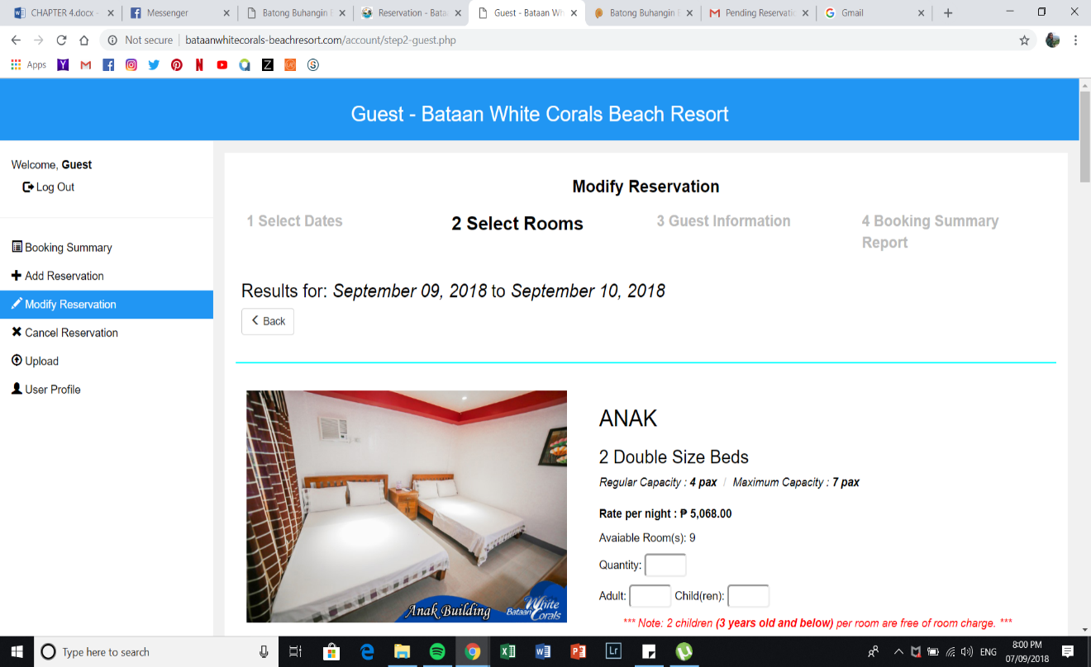*Figure 83: Guest Modify Reservation Page (Select Rooms)*

This is where the guests will select their desired room and indicate the quantity of room, adult, and children.

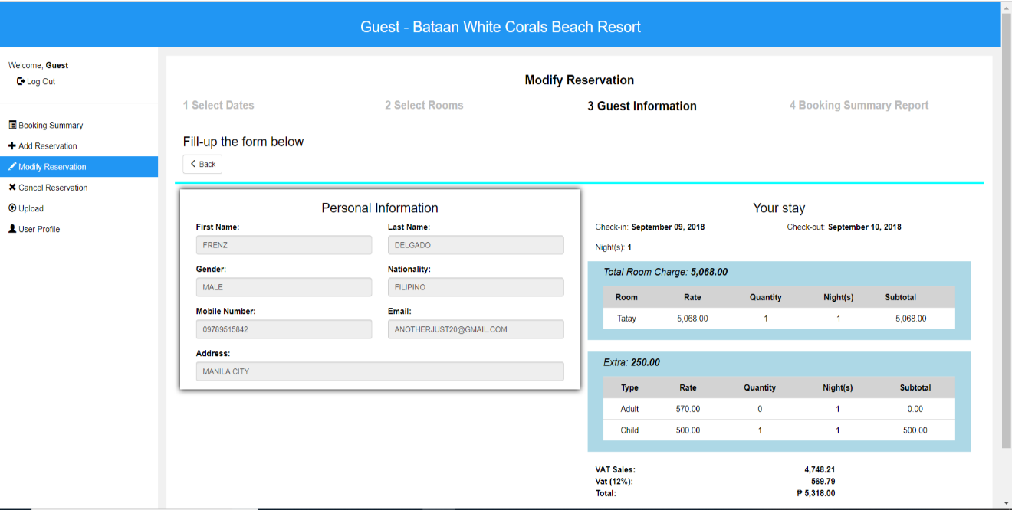*Figure 84: Guest Modify Reservation Page (Guest Information)*

It displays the personal information of the guest who is logged in and the summary of the guest’s stay.

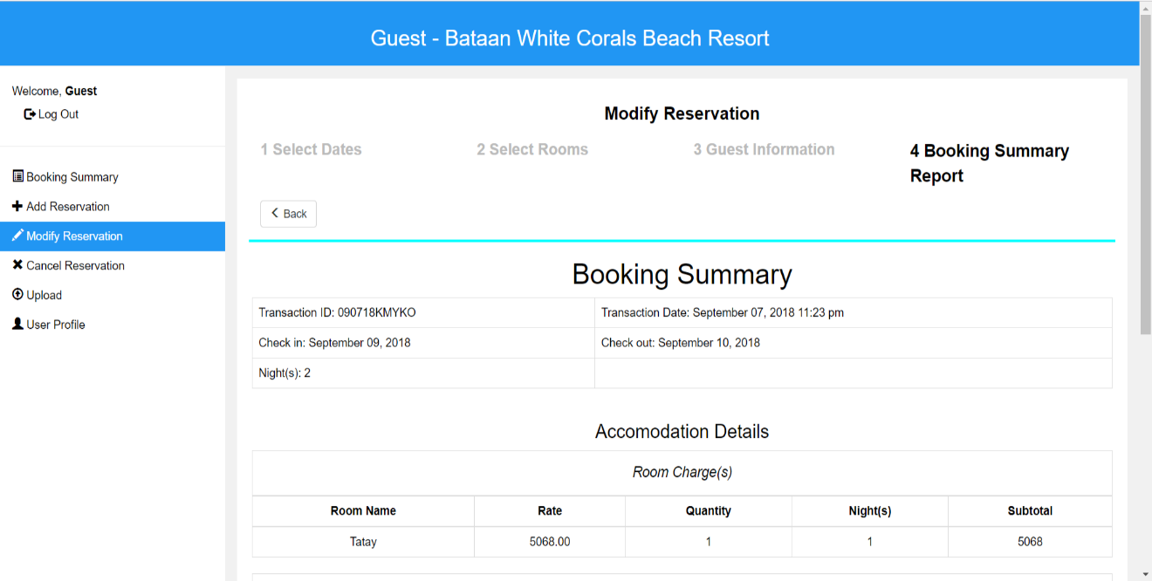

*Figure 85: Guest Modify Reservation Page (Booking Summary - Part 1)*

It displays the modified booking summary reserved by the guest who includes the transaction id, date and time, check-in and out date. Also, the number of nights the guest wants to avail.

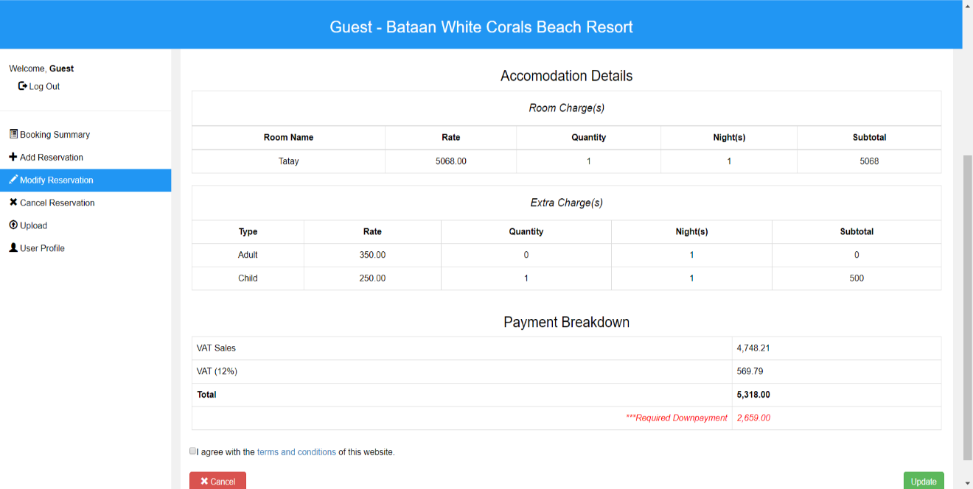

*Figure 86: Guest Modify Reservation Page (Booking Summary - Part 2)*

It displays the modified booking summary reserved by the guest as well as the modified accommodation details where the room and extra charge/s, payment breakdown are displayed.

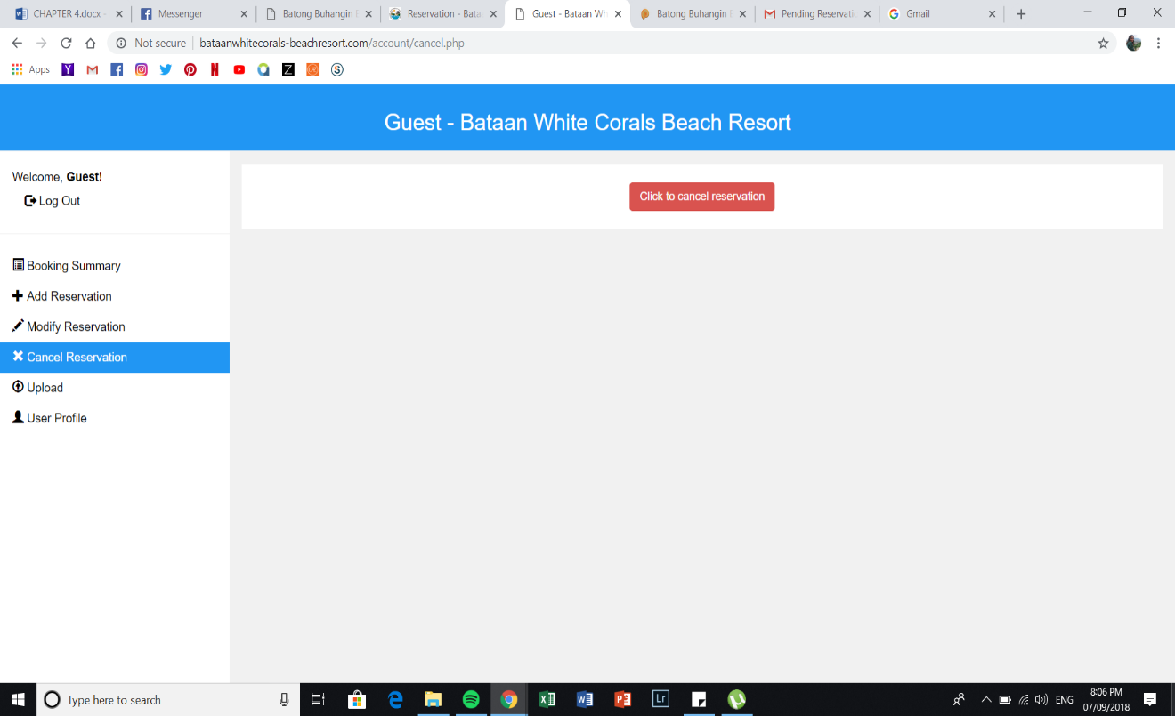

*Figure 87: Guest Cancel Reservation Page (Part 1)*

It shows that the guest can cancel their reservation by simply clicking the button and confirms the guest if he/she is sure to delete the reservation.

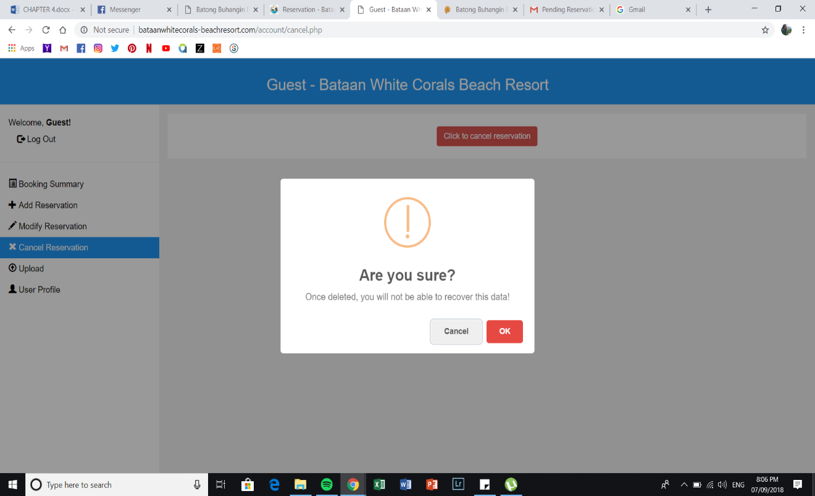*Figure 88: Guest Cancel Reservation Page (Part 2)*

After clicking the button, it will notify and show the guest if he/she will cancel their reservation.

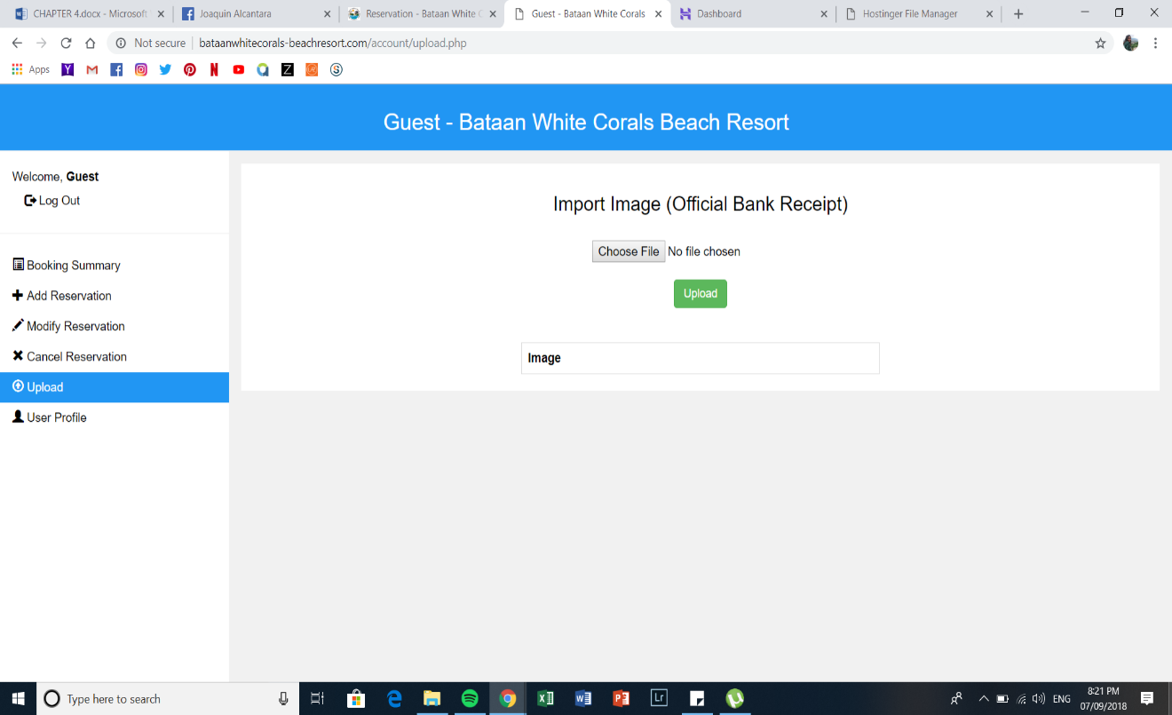*Figure 89: Guest Upload Page*

This module gives the guest an ability to upload an image for the bank receipt which is the basis or proof of payment that the admin will confirm after.

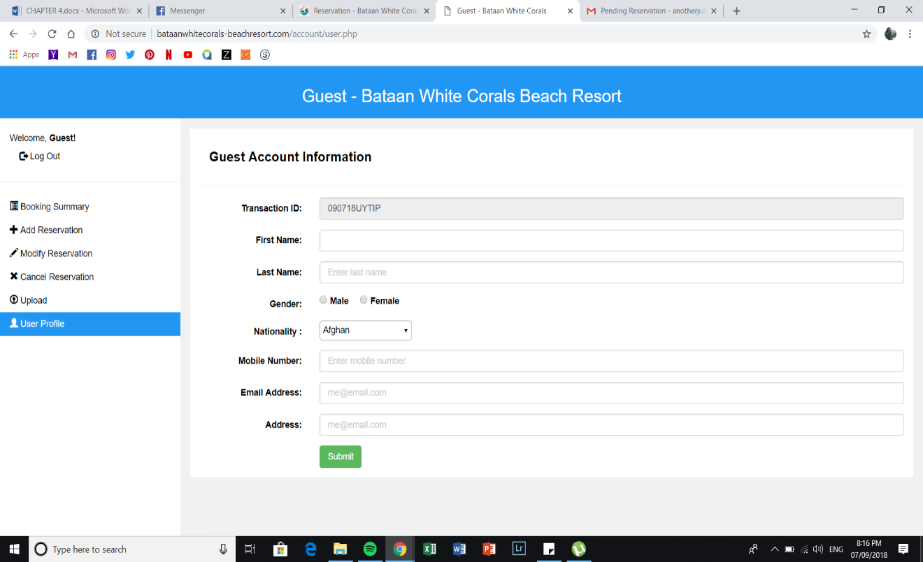*Figure 90: User Profile Page*

This module displays guest account information where the guest can modify his/her personal details.

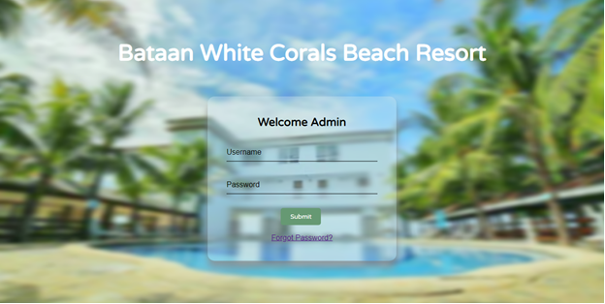*Figure 91: Admin Login Account*

This figure shows the log-in page of the admin where username and password are needed in order to access the admin’s account.

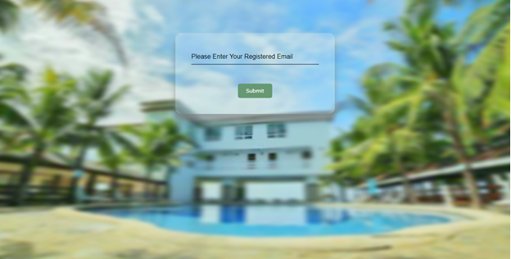

*Figure 92: Admin Login Account (Forgot Password)*

It shows the forgotten password page of the admin where registered email address of the user is required to confirm and send a link in order to change his/her password.

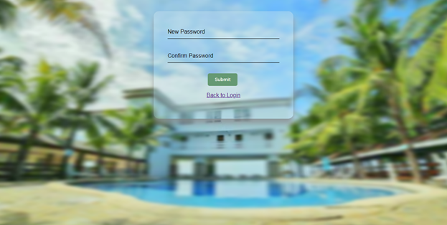

*Figure 93: Admin Login Account (New Password)*

Displays the new password page of the admin where the user must provide his/her new password and retype it to confirm if the new password is the same.

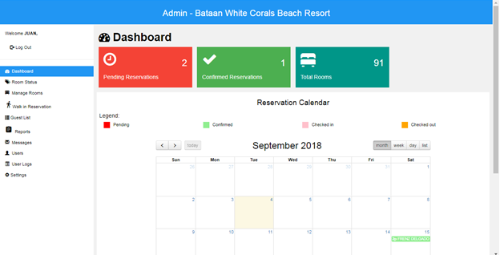*Figure 94: Admin’s Dashboard*

This module shows the admin’s overview of the dashboard where it displays the pending and confirmed reservations, total rooms and reservation calendar which can be filtered by day, week, month and list it also provides a legend for the admin.

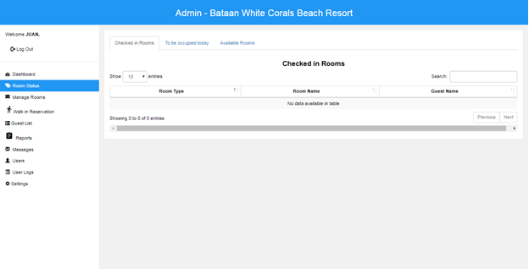*Figure 95: Admin’s Room Status (Checked in Rooms)*

It allows the admin to view the summary of rooms and display the specific type and name of the room which is occupied by the guest.

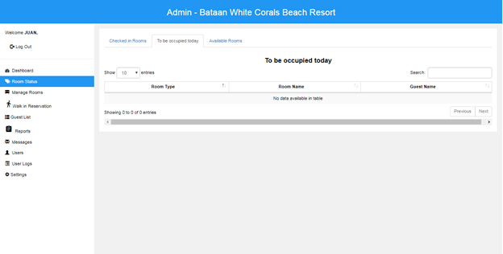*Figure 96: Admin’s Room Status (To be occupied today)*

It shows the summary of rooms that are occupied within the day and display the specific type and name of the room and guest’s name.

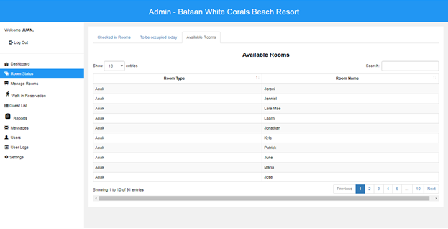 *Figure 97: Admin’s Room Status (Available Rooms)*

This figure shows the lists of all the available rooms that can be occupied by the guest.

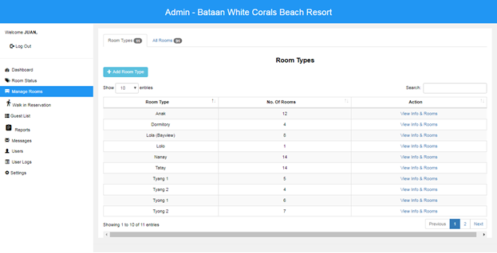

*Figure 98: Admin’s Manage Rooms*

Indicates all types of room that Bataan White Corals Beach Resort has and it consists of room type, number of rooms and action that can be clicked and viewed by the admin to see the overall details of the specific room.

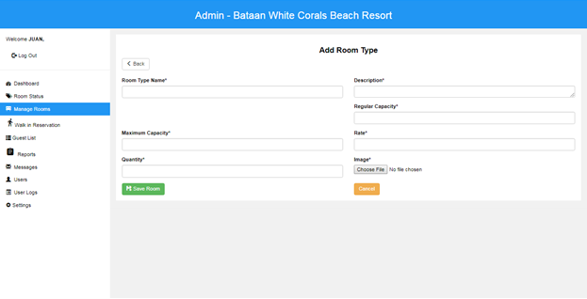*Figure 99: Admin’s Manage Rooms (Add Room Type)*

It shows the capability of the admin to add a room type. The admin provides details of the new room such as type name, description, maximum capacity, regular capacity, quantity, rate, and image.

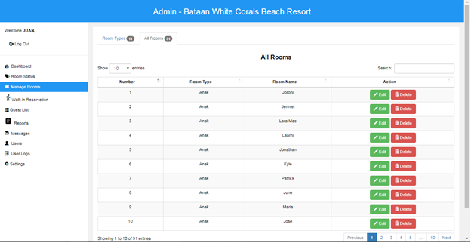*Figure 100: Admin’s Manage Rooms (All Rooms)*

Displays and lists all the rooms offered by the resort and the admin can view, edit and delete the specific room.

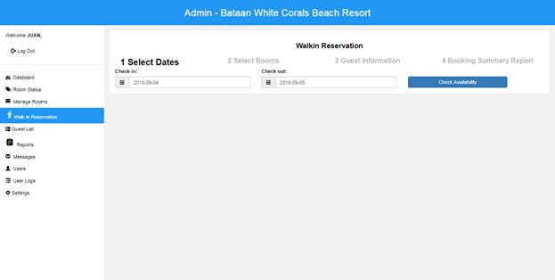*Figure 101: Admin’s Walk-in Reservation (Select Dates)*

The step by step reservation for walk-in guests. The first procedure is that guest must choose his/her desired check-in and check-out dates.

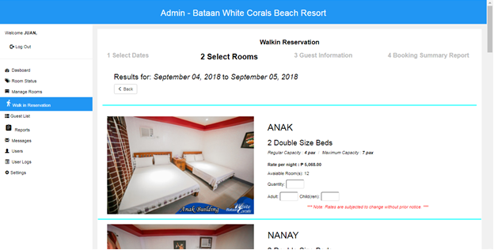*Figure 102: Admin’s Walk-in Reservation (Select Rooms)*

The second procedure by availing or selecting a room that guest wants to reserve and occupy.

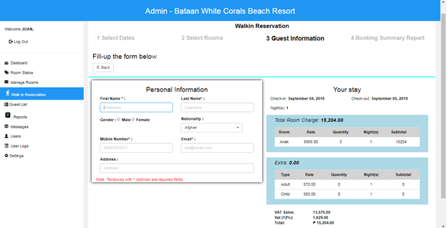*Figure 103: Admin’s Walk-in Reservation (Guest Information)*

The third procedure that guests must provide their personal information such as the first and last name, gender, nationality, address, mobile number and email in order to address them correctly. Also, it displays the summary of the guests stay which consists of the total room charge, extra charge/s, VAT sales and VAT.

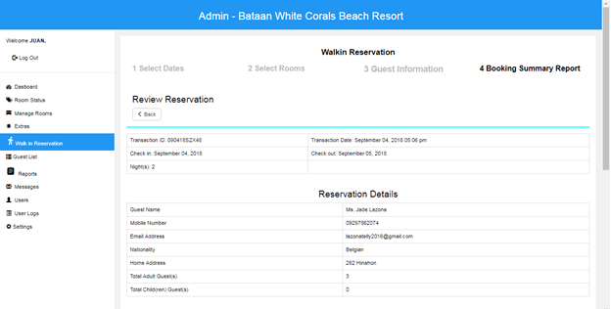*Figure 104: Admin’s Walk-in Reservation (Booking Summary Report)*

The summary of the guest’s reservation displays the Transaction Id and date, check-in and check-out dates, total nights reserved. It also shows the guests' details such as the name, mobile number, email address, nationality, home address, total adult and child(ren) guests. In addition to that, under the payment breakdown it displays the VAT sales, VAT, total and required down payment that guest must pay.

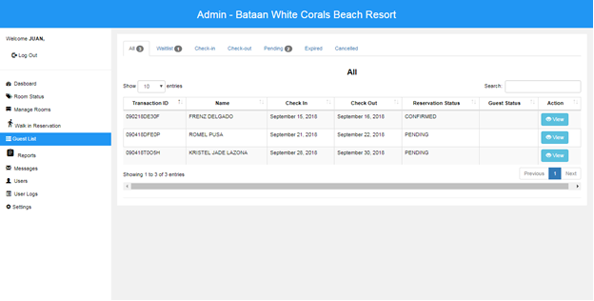*Figure 105: Admin’s Guest List*

Displays the summary or list of guests for the admin. The admin can sort, search and view a specific data or information.

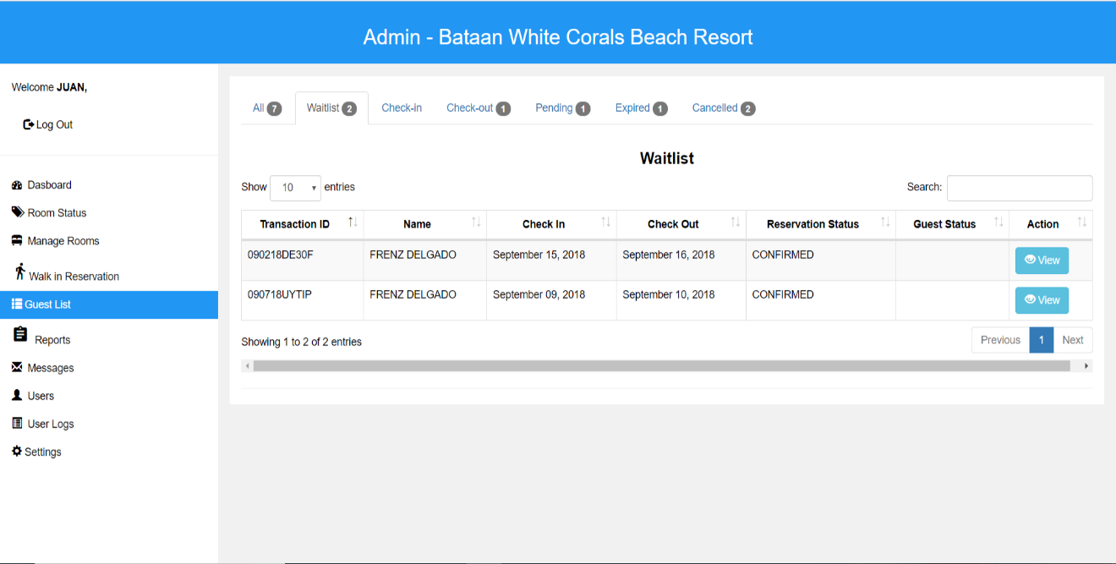*Figure 106: Admin’s Guest List (Waitlist)*

Shows the list of guests who are in the waitlist and displays the transaction ID, name of the guest, check in and out date, reservation and guest status.

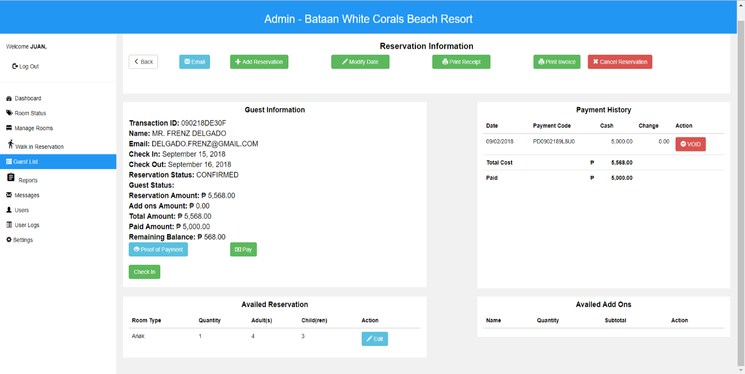*Figure 107: Admin’s Guest List (Reservation Information)*

After clicking the view button in the guest list module of the admin, it will show the reservation information of the guest such as the guest and availed reservation, payment history and availed add ons of the guest. The admin can also email, add a reservation, modify the date, print the receipt and invoice and cancel the guest’s reservation.

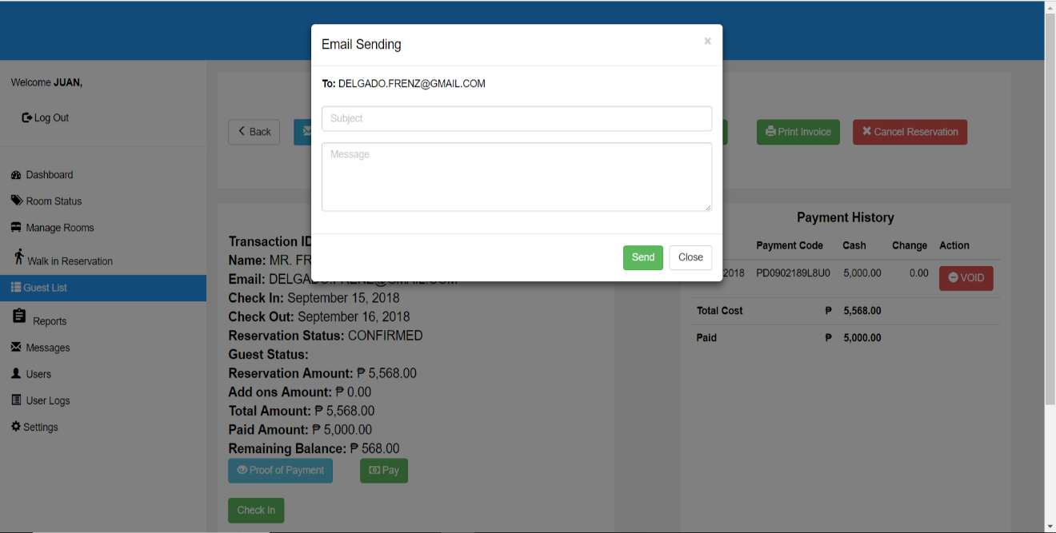

*Figure 108: Admin’s Guest List (Reservation Information - Email)*

After clicking the email button in the reservation information module, the admin can send an email to the guest.

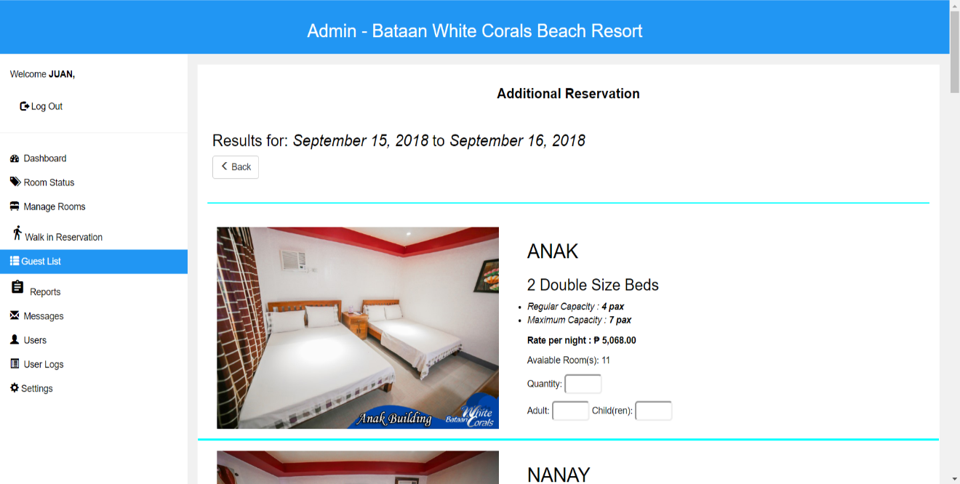*Figure 109: Admin’s Guest List (Reservation Information - Add Reservation)*

After clicking the add reservation button in the reservation information module, it will direct the admin in adding a reservation for the guest, where the guest wants to avail a room and add to their reservation.

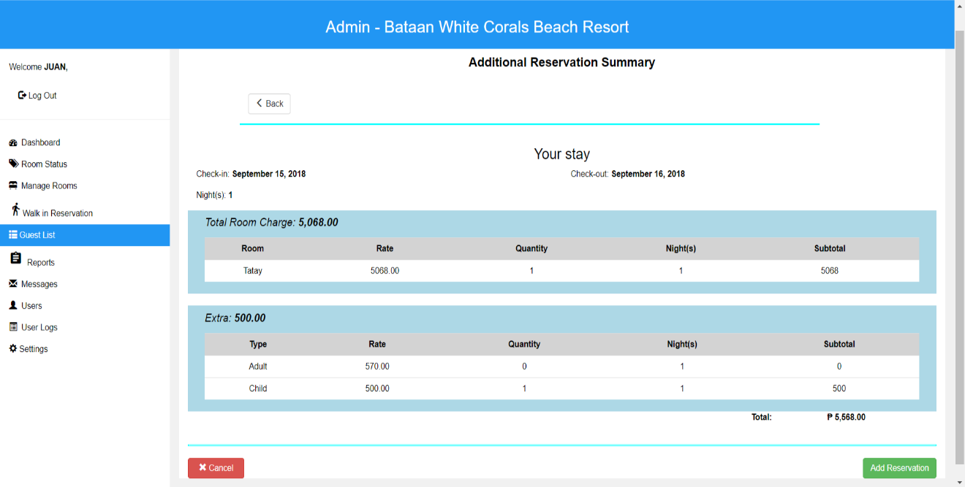*Figure 110: Admin’s Guest List (Reservation Information - Add Reservation Summary)*

After the guests chose their additional desired room, it will show the summary of the room’s total charge as well as the extra charges that the guest must pay.

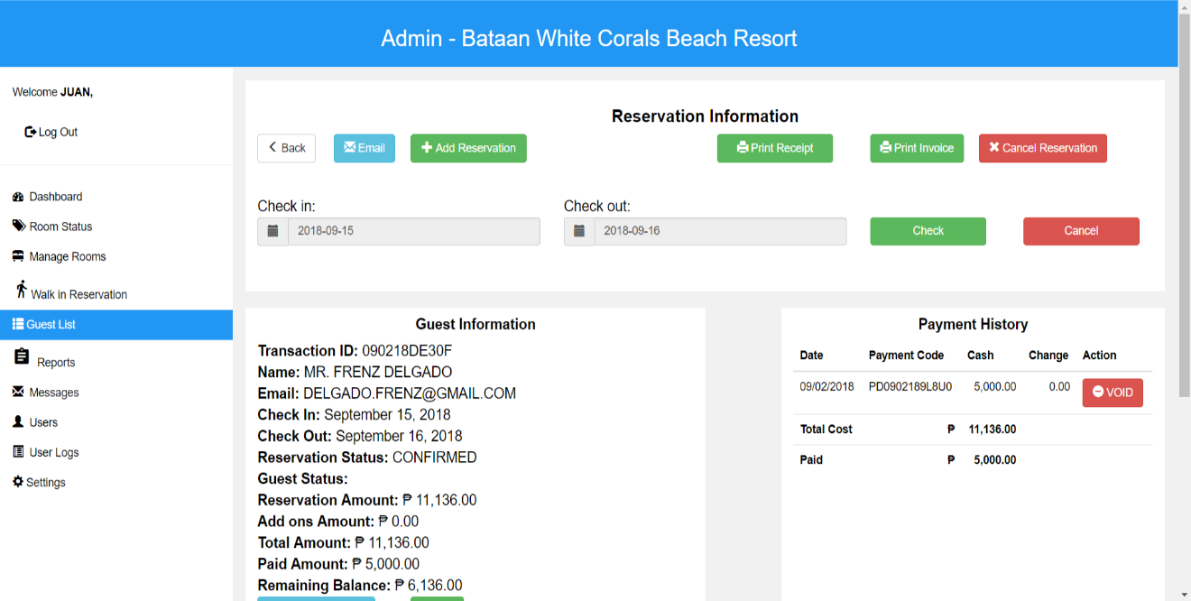*Figure 111: Admin’s Guest List (Reservation Information - Modify Date)*

Clicking the modify date button in the reservation information of the guest list module, it will show display the check in and out date that the admin can edit for the guest.

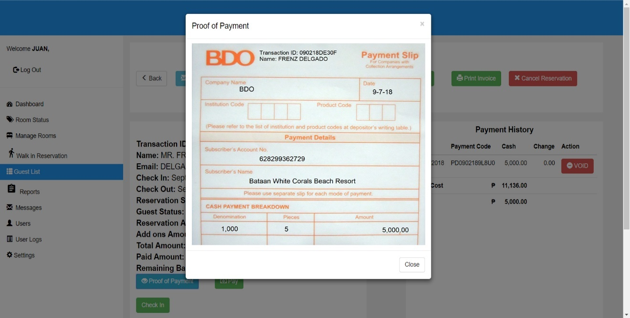*Figure 112: Admin’s Guest List (Reservation Information - Proof of Payment)*

Clicking the proof of payment button in the guest information of the guest list module, it will show the uploaded image by the guest where the admin can view.

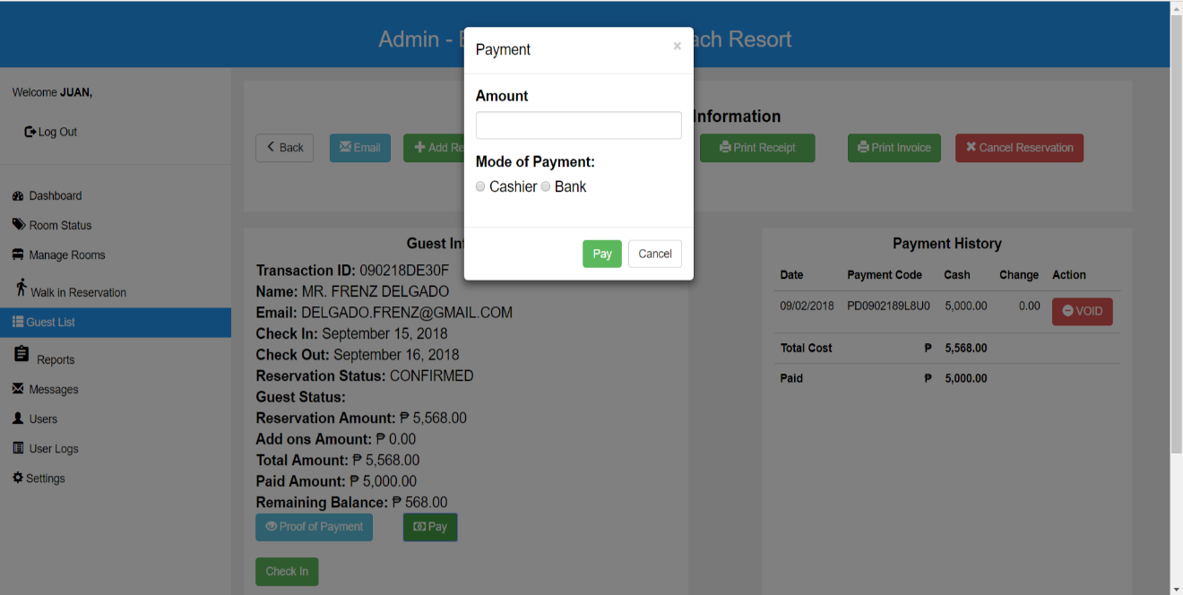

*Figure 113: Admin’s Guest List (Reservation Information - Payment)*

Clicking the pay button in the guest information of the guest list module, the admin will input the amount paid by the guest and he/she will indicate if the mode of payment is through bank or cashier.

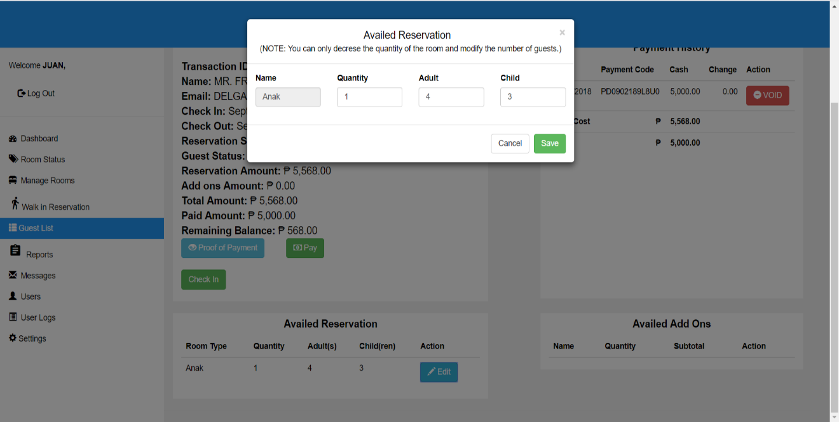*Figure 114: Admin’s Guest List (Reservation Information - Availed Reservation)*

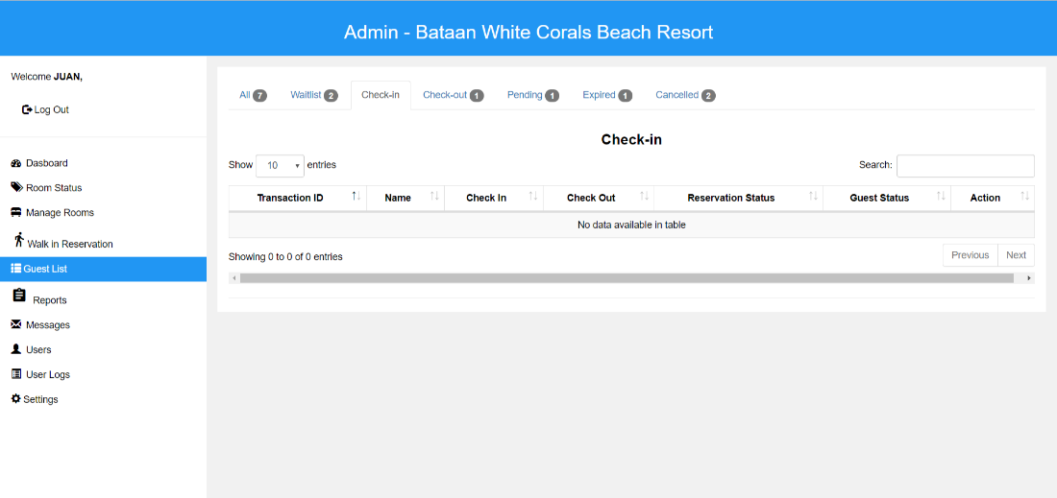Clicking the edit button in the availed reservation information of the guest list module, the admin will only modify and input the quantity, adult and child that the guest desires.

*Figure 115: Admin’s Guest List (Check In)*

Displays the table or list of guests who are checked in. It includes also the transaction ID, name of the guest, check in and out date, reservation and guest status that can be viewed by the admin.

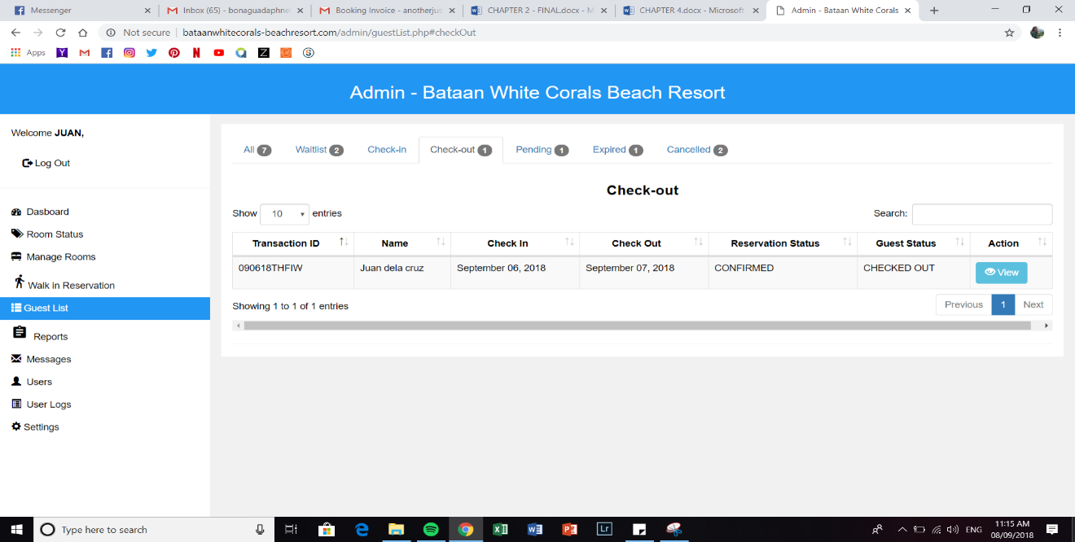*Figure 116: Admin’s Guest List (Check Out)*

List of guests who checked out in the resort where the transaction ID, name of the guest, check in and out date, reservation and guest status are displayed.

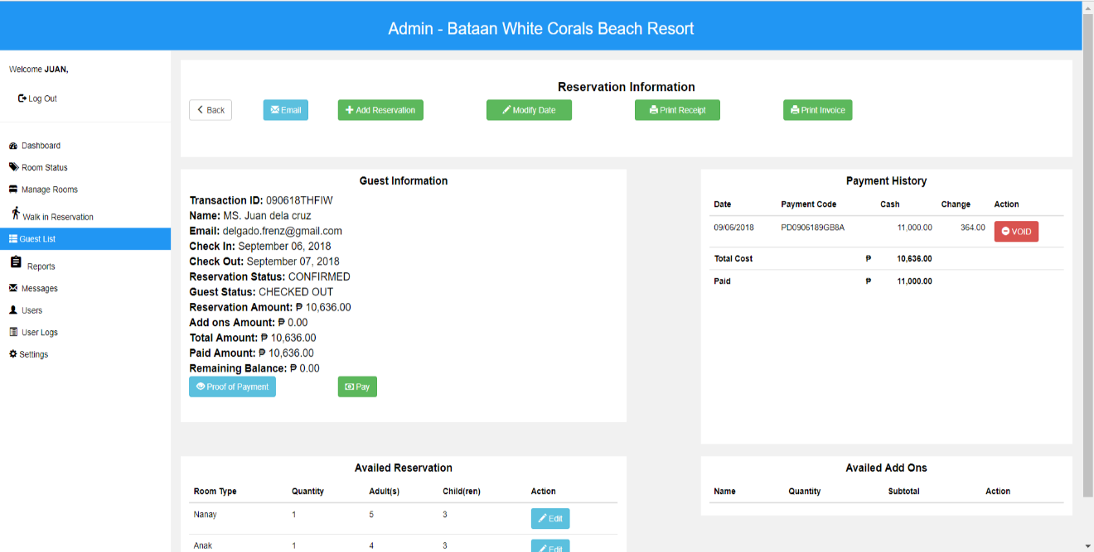*Figure 117: Admin’s Guest List (Check Out - Reservation Information)*

After clicking the view button in the check-out module, it will show the summary of reservation information of the guest such as the guest and availed reservation, payment history and availed add ons of the guest.

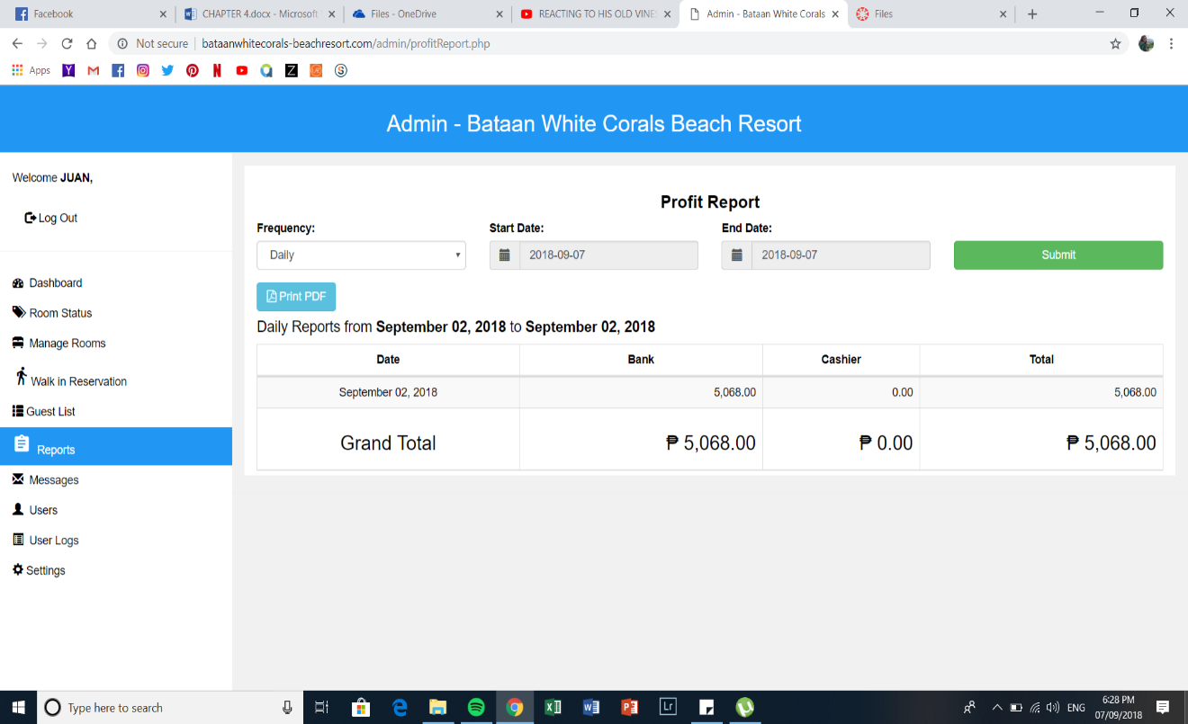

*Figure 118: Admin’s Reports Page (Profit Report - Daily)*

The daily profit report which the admin can view from the admin’s reports page indicating the date, mode of payments such as through bank and cashier and display the total profit earned within the day. It also lets the admin print a PDF of the report.

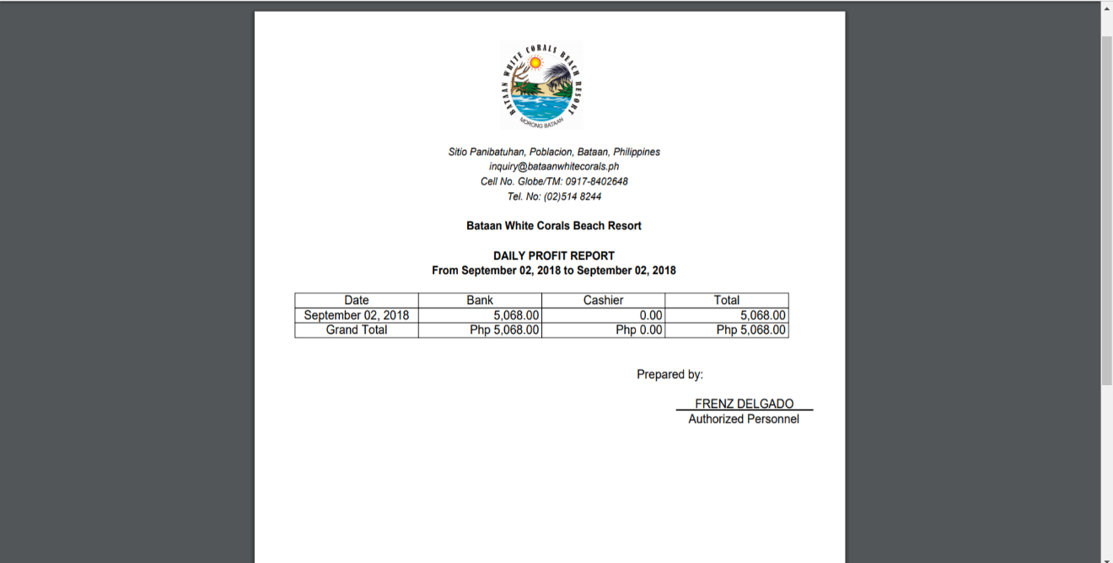

*Figure 119: Admin’s Reports Page (Profit Report PDF - Daily)*

Shown above is the generated report of the daily profit report listing the date, mode of payments such as bank and cashier and the total profit earned by the resort. The admin can also print and have a hard copy of it.

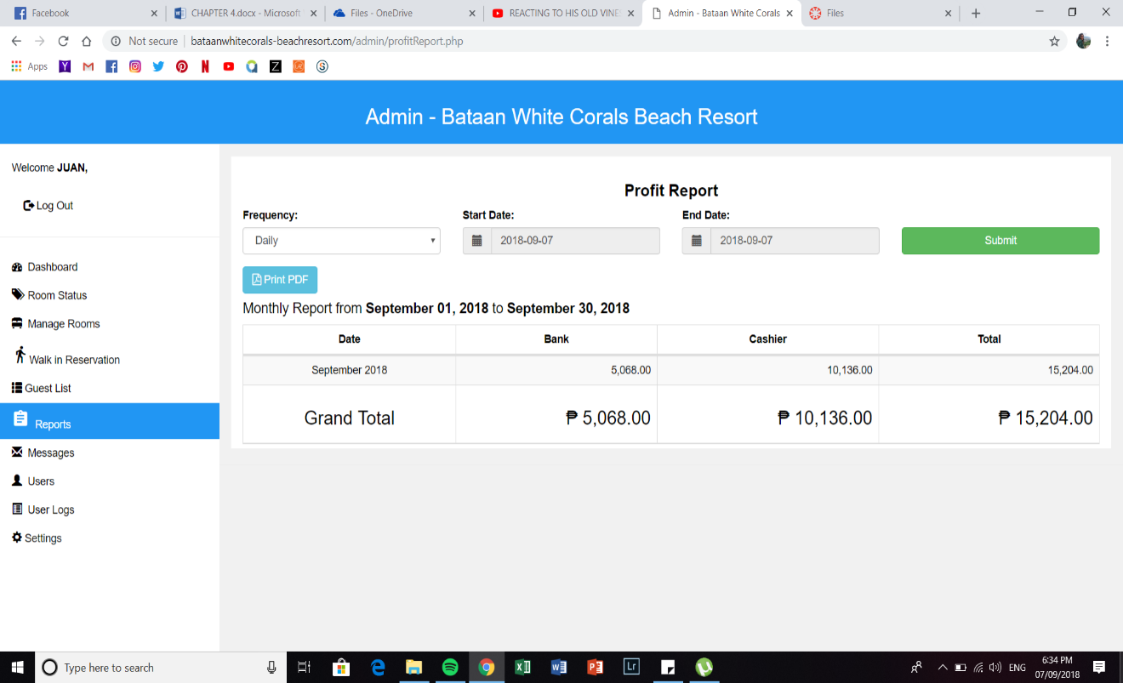*Figure 120: Admin Reports Page (Profit Report - Monthly)*

The monthly profit report which the admin can view from the admin’s reports page indicating the date, mode of payments such as through bank and cashier and display the total profit earned within the month. It also lets the admin print a PDF of the report.

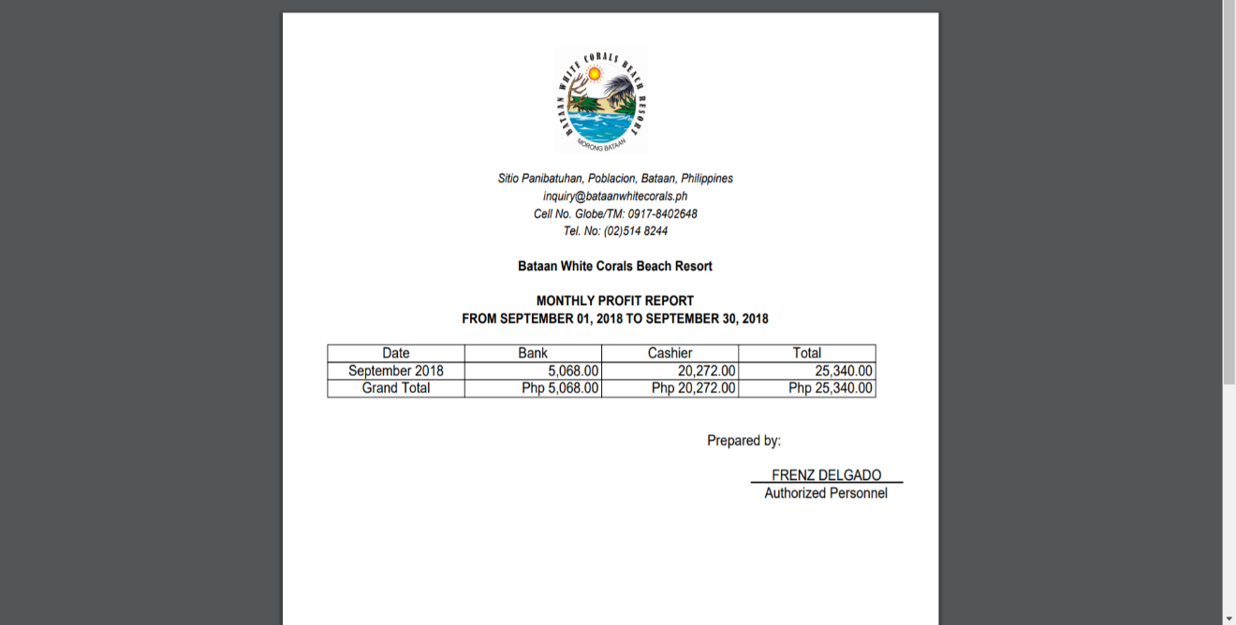

*Figure 121: Admin’s Reports Page (Profit Report PDF - Monthly)*

Shown above is the generated report of the monthly profit report listing the dates, mode of payments such as bank and cashier and the total profit earned. The admin can also print and have a hard copy of it.

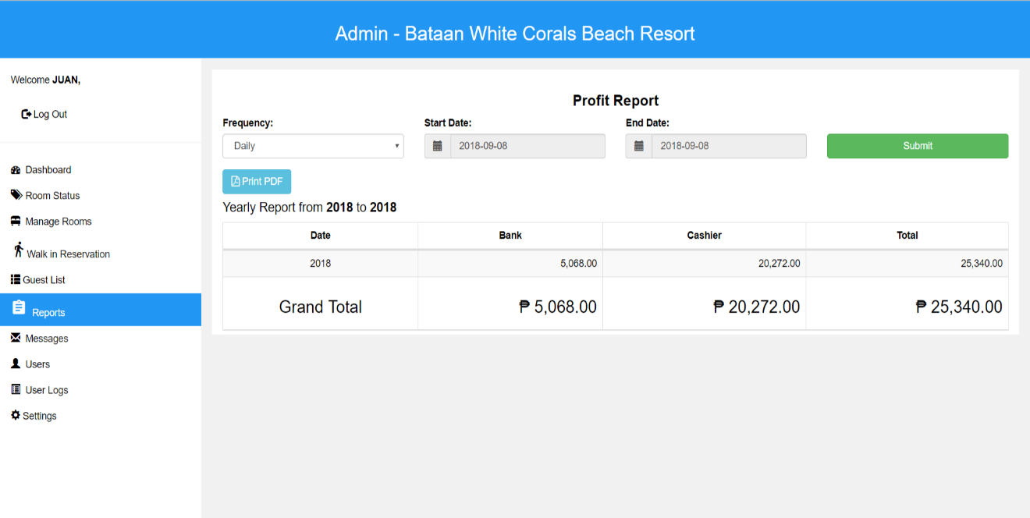*Figure 122: Admin Reports Page (Profit Report - Yearly)*

The yearly profit report which the admin can view from the admin’s reports page indicating the date, mode of payments such as through bank and cashier and display the total profit earned within the month. It also lets the admin print a PDF of the report.

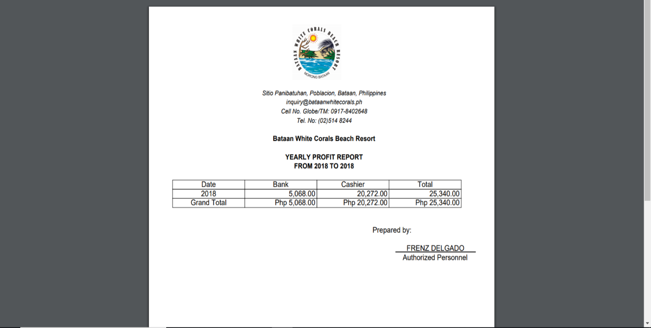

*Figure 123: Admin’s Reports Page (Profit Report PDF - Yearly)*

Shown above is the generated report of the monthly profit report listing the year, mode of payments such as bank and cashier and the total profit earned. The admin can also print and have a hard copy of it.

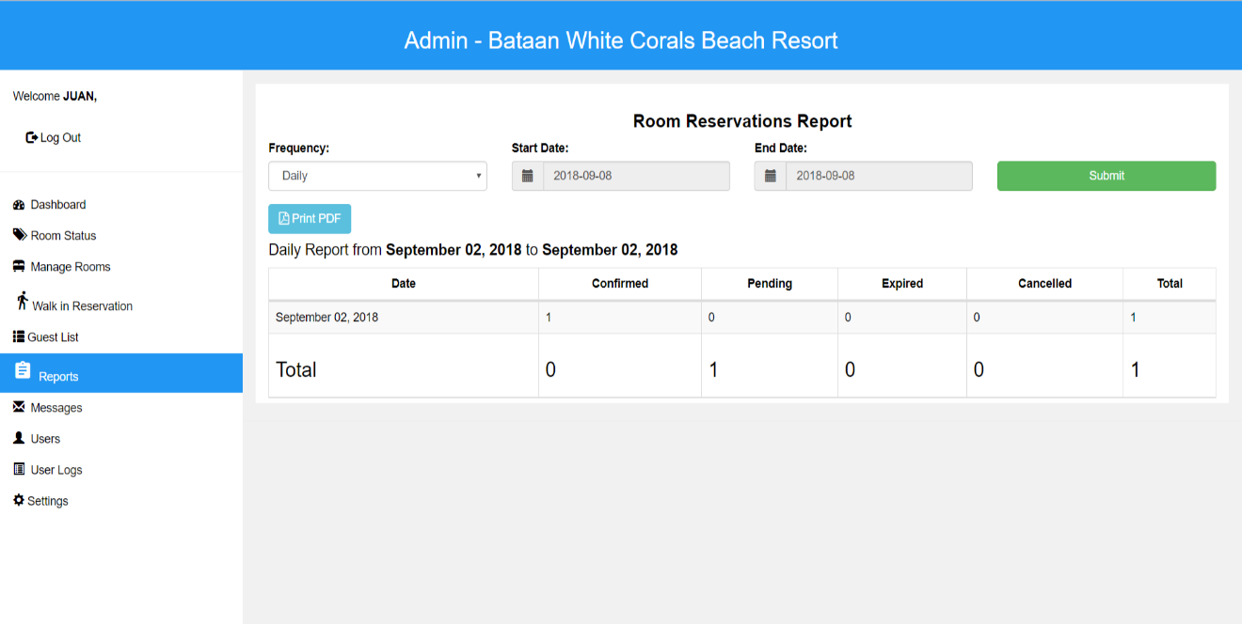*Figure 124: Admin Reports Page (Room Reservations Report - Daily)*

The daily room reservations report which the admin can view the summary from the admin’s reports page indicating the date, numbers of confirmed, pending, expired and cancelled reservation. It also lets the admin print a pdf of the report.

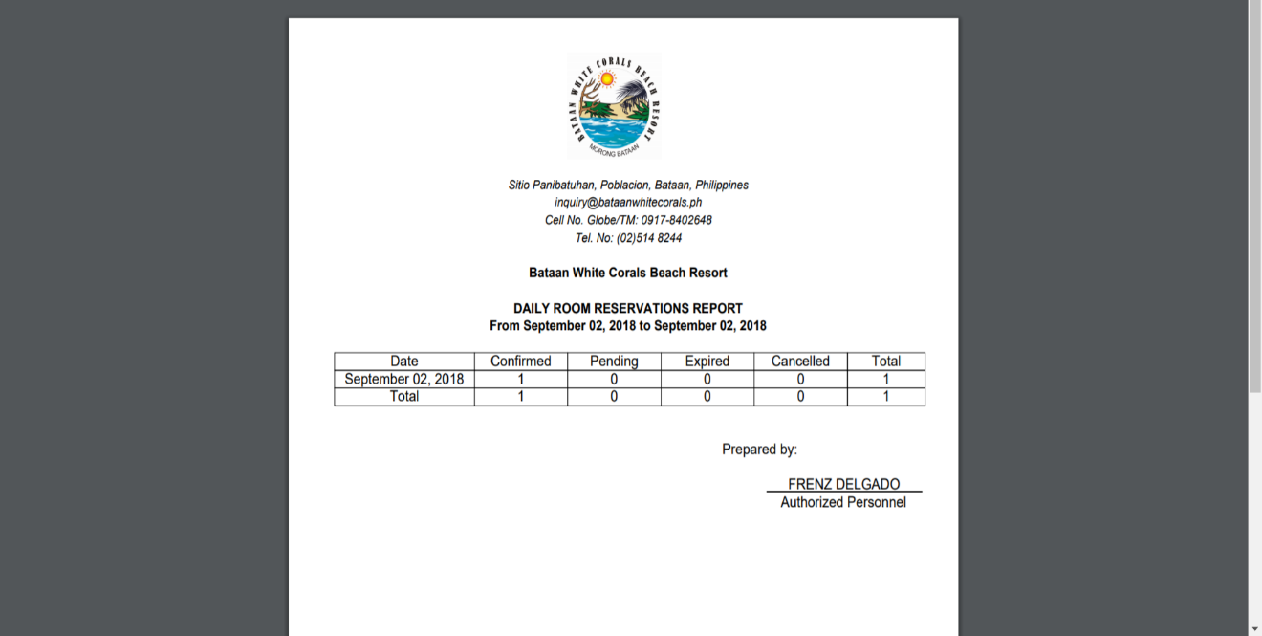

*Figure 125: Admin’s Reports Page (Room Reservations PDF- Daily)*

The generated report of the daily room reservations report listing the date, numbers of confirmed, pending, expired and cancelled reservation as well as the total number of rooms reserved within the day.

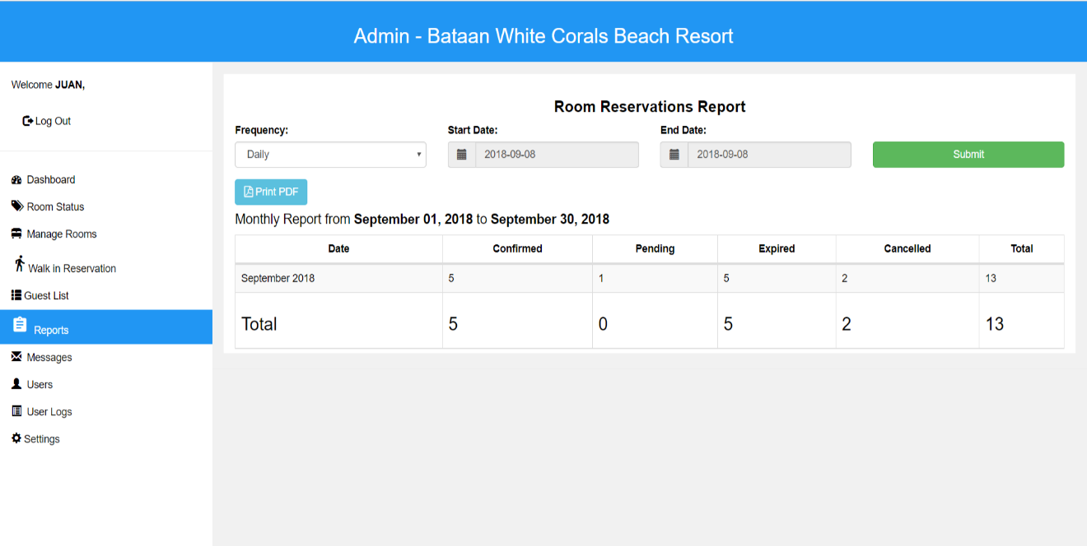*Figure 126: Admin Reports Page (Room Reservations Report - Monthly)*

The monthly room reservations report which the admin can view the summary from the admin’s reports page indicating the date, numbers of confirmed, pending, expired and cancelled reservation. It also lets the admin print a pdf of the report.

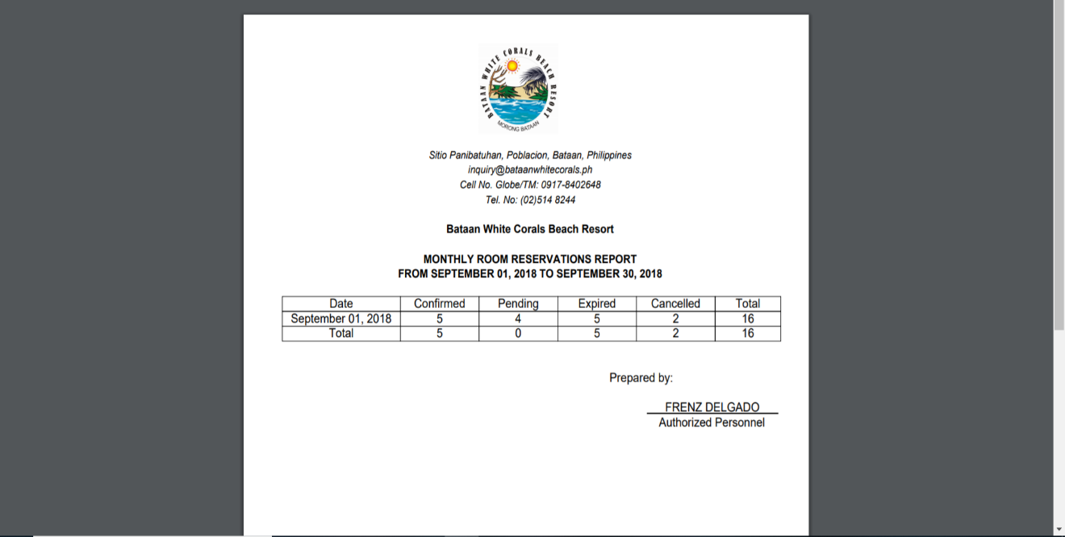

*Figure 127: Admin’s Reports Page (Room Reservations PDF- Monthly)*

The generated report of the monthly room reservations report listing the date, numbers of confirmed, pending, expired and cancelled reservation as well as the total numbers of room reserved within the month.

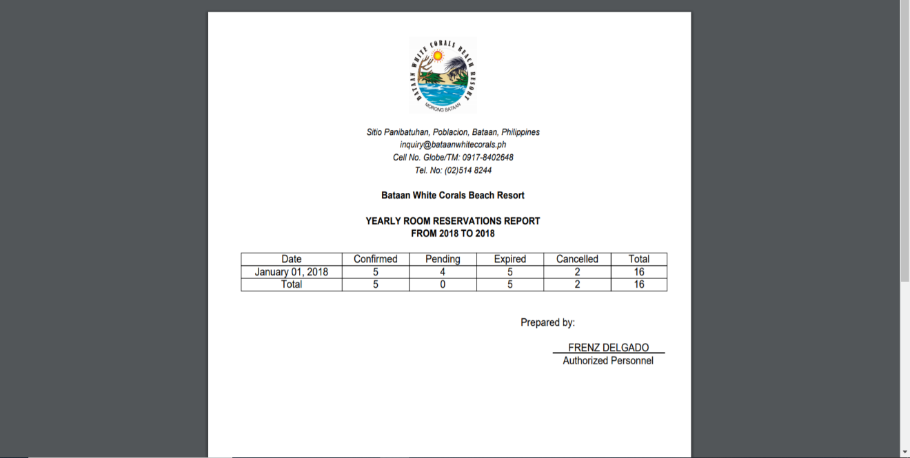

*Figure 128: Admin Reports Page (Room Reservations Report - Yearly)*

The yearly room reservations report which the admin can view the summary from the admin’s reports page indicating the date, numbers of confirmed, pending, expired and cancelled reservation. It also lets the admin print a pdf of the report.

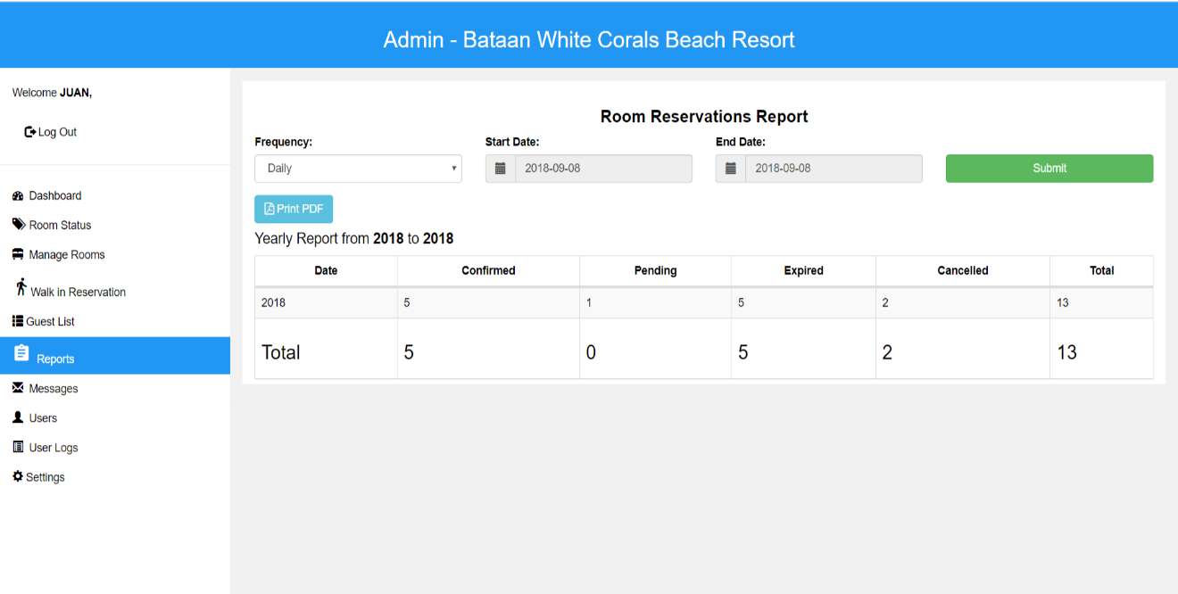

*Figure 129: Admin’s Reports Page (Room Reservations PDF- Yearly)*

The generated report of the yearly room reservations report listing the date, numbers of confirmed, pending, expired and cancelled reservation as well as the total numbers of room reserved within the year.

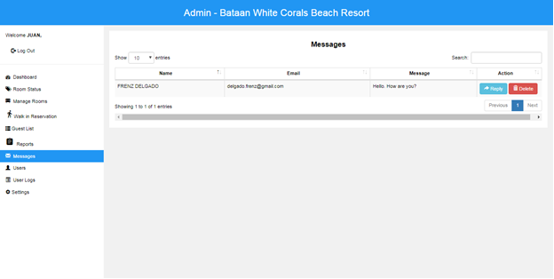*Figure 130: Admin’s Messages*

Messages that the admin can simply interact with the guest such as replying for inquiries, concerns and suggestions as well as deleting a specific message given by the guest.

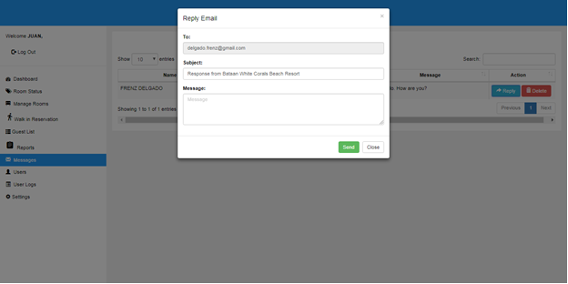*Figure 131: Admin’s Messages (Reply Email)*

The admin’s view of replying to the guest, it must consist of a “to” field, subject and message.

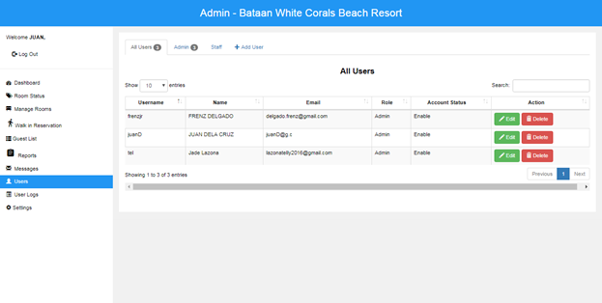*Figure 132: Admin’s Users Page*

Shows all registered users and their details. Also, the admin can edit and delete the information of the user.

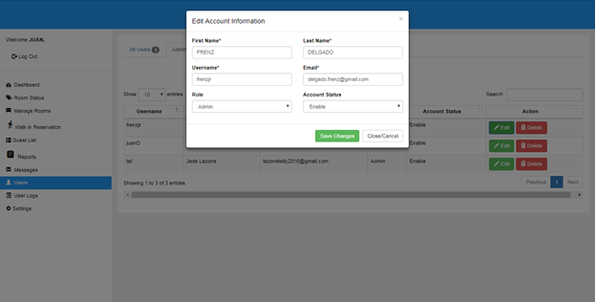*Figure 133: Admin’s Users Page (Edit Account Information)*

This figure shows the edit account information which the admin can modify the name, username, email, role and the account status of the user.

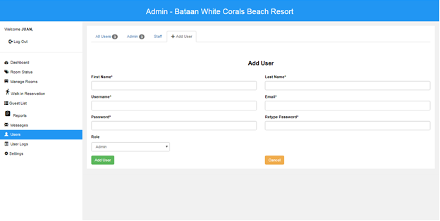*Figure 134: Admin’s Users Page (Add User)*

It shows that the admin can simply add a new user for the Bataan White Corals Beach Resort just providing the first and last name, username, email, password, and the assigned role of the user.

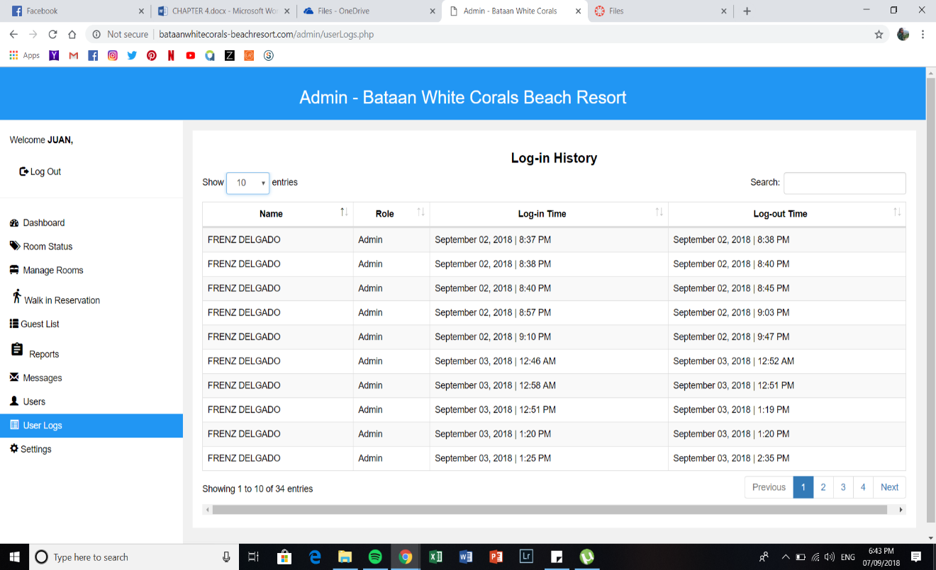*Figure 135: Admin User Logs Page*

Lists the log-in history from the admin’s user log page and list the registered account and his/her role.

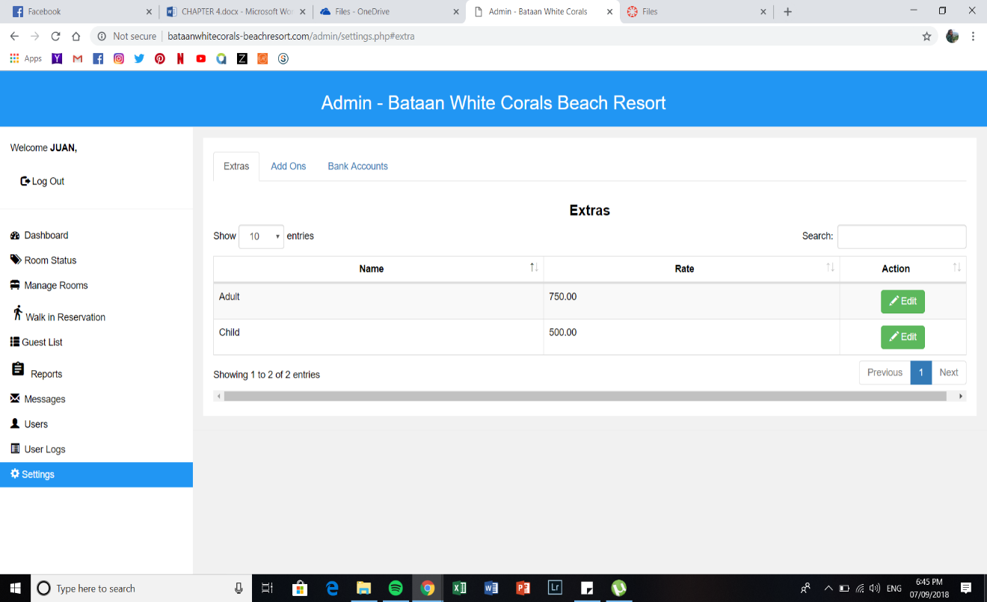*Figure 136: Admin Settings Page (Extras)*

The admin settings page shows the rate of the adult and child when there are instances that the guest has an extra person with them.

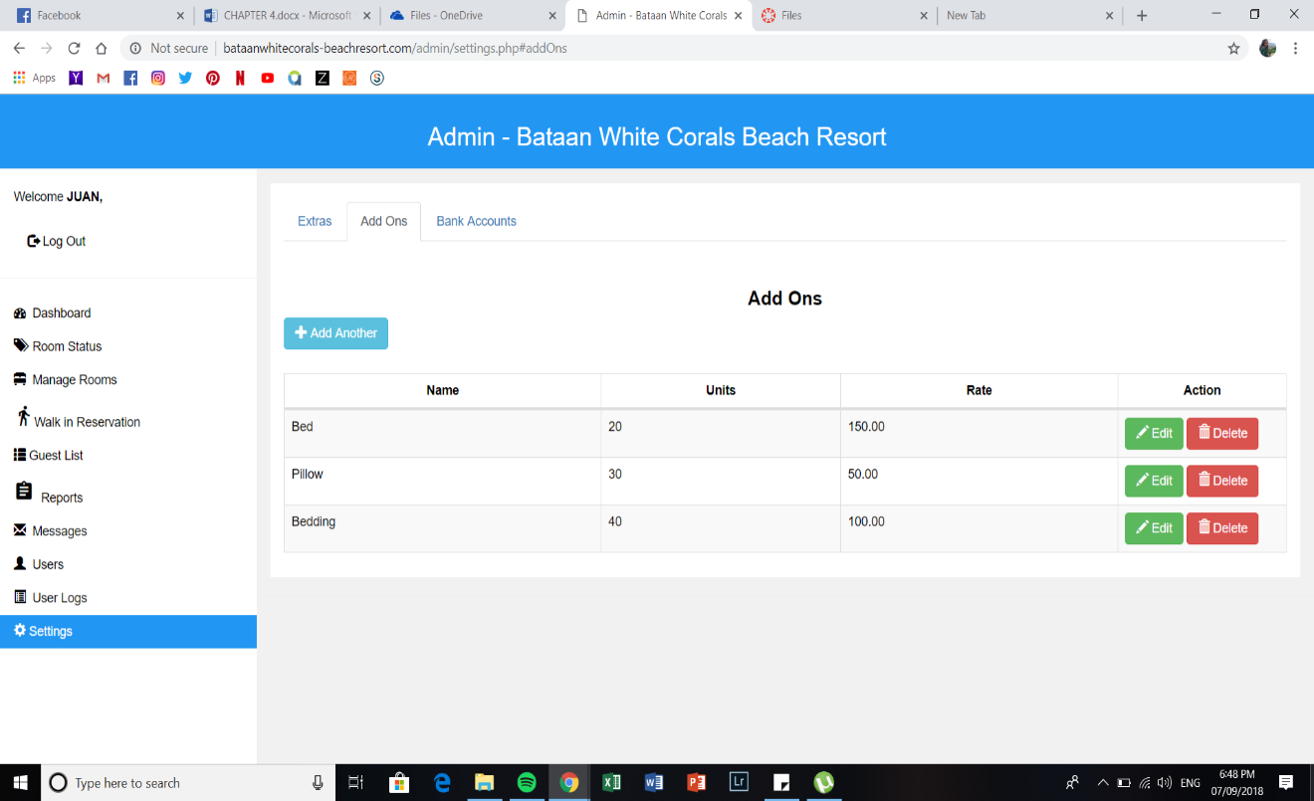*Figure 137: Admin Settings Page (Add Ons)*

Shows that the admin can add, edit, view a list of add ons that the guest might avail once they are checked in. It also allows the admin to delete it.

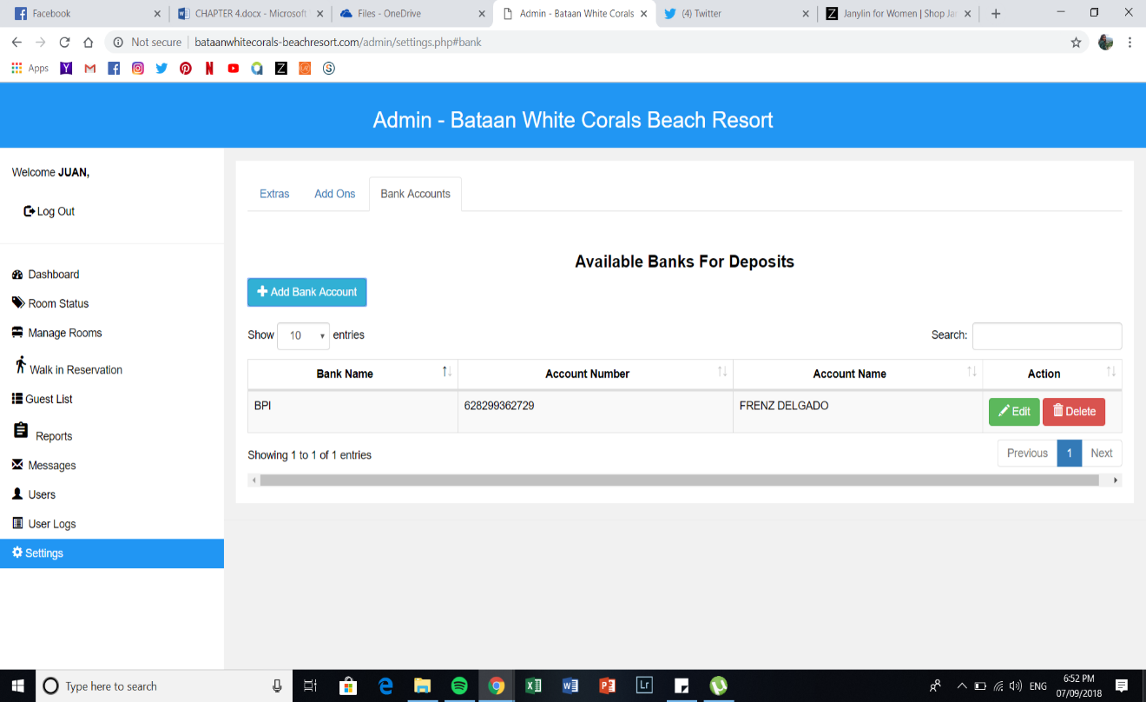*Figure 138: Admin Settings Page (Bank Accounts)*

It allows the admin to add a new bank account and place their personal bank account.

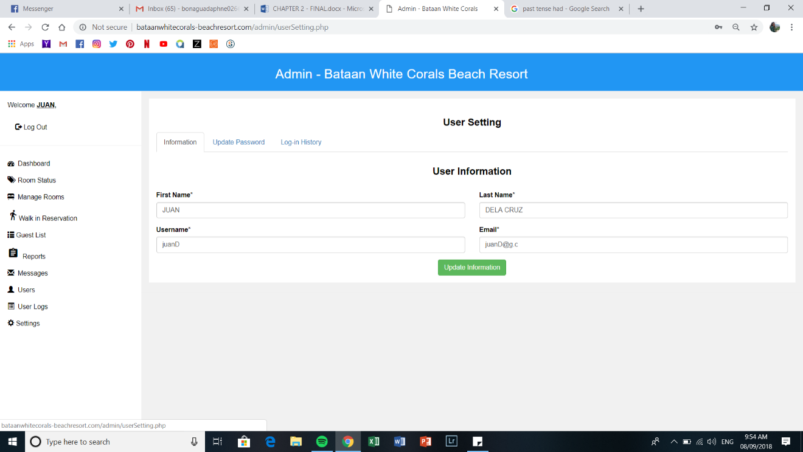*Figure 139: Admin User Settings (Information)*

Once, the admin clicked his/her name above the log-out button it will direct to the user settings where the admin can modify or edit his/her personal details.

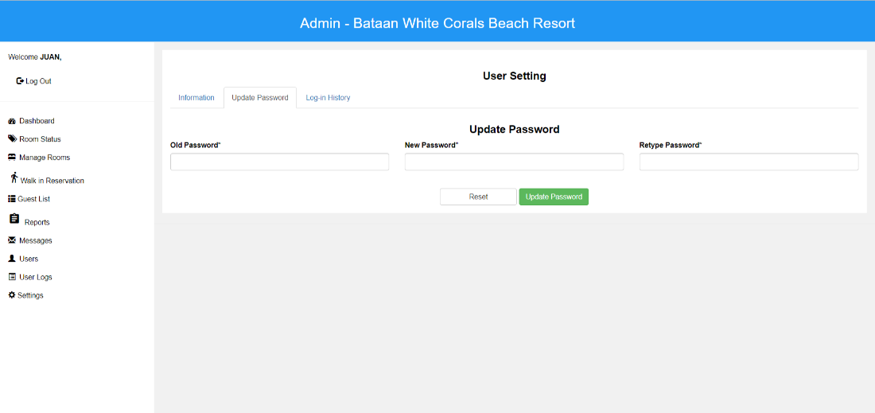

*Figure 140: Admin User Settings (Update Password)*

The admin can change his/her desired password by inputting the old password and change his/her new password

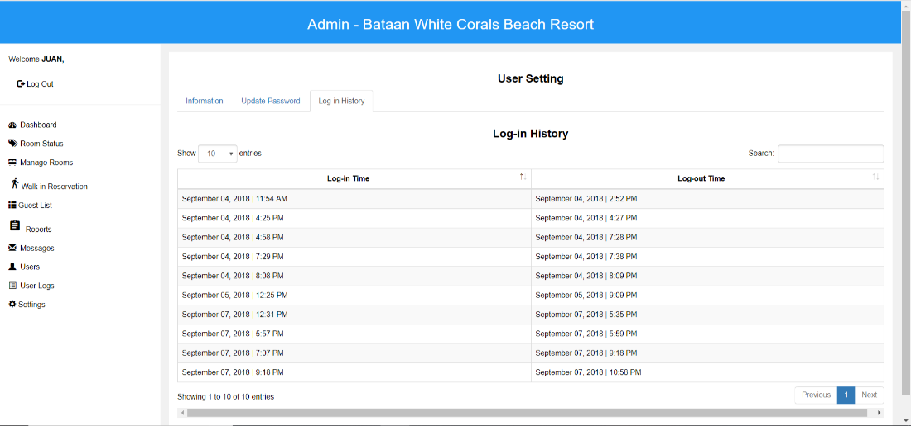

*Figure 141: Admin User Settings (Log-in History)*

This shows the history of the admin on what date and time he/she logged in and out.

**PROJECT CAPABILITIES**

The system that the proponents developed for Bataan White Corals Beach Resort has the ability to handle guest’s reservation and transactions. As well as giving daily, weekly, monthly, and yearly reports for the company that helps them to track their own profit and the day to day flow of their resort.

**Website**

* It includes reservation and other transactions in the website.
* It shows all the different rooms offered by the resort including a brief information of the room.
* Rates of the resort are also included in order for the guest to see instantly on what the resort offers.
* Contact module that helps to communicate with the employees of the resort.

**Reservation**

* It lets the guest to view and avail what room/s they want to reserve.
* The system sends an email confirmation and updates regarding the guest’s reservation.

**Transaction**

* Bank deposit is one of the payments that can be made, it allows guest to upload an image of their deposit slip.
* Through cash is also a method of payment, the admin will simply use and log-in to their account and a walk-in module is included.
* Total amount of guest’s reservation is computed and displayed.

**User/Admin Account**

* The user has a limited access in the module of the system.
* The admin can access all the modules in the system.

**Reports**

* The system can provide reports such as profit and room reservation.

**Testing and Evaluation Result**

This section presents the results of the evaluation procedure. Data were presented in a table format and interpretations were included.

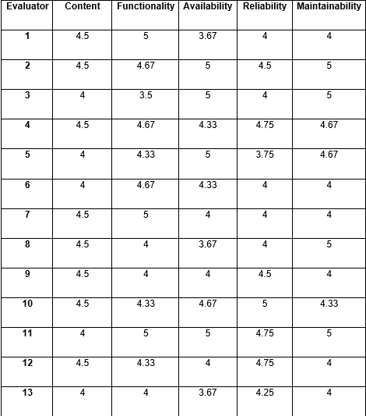 The system was evaluated by the owner of the Bataan White Corals Beach Resort and Ten (10) IT Professionals. The proponents also got the perspective of the students concerning the system by doing some survey with the students from IT. The proponents decided to choose them for they are capable of understanding and deducing the developed system. The testing and evaluating results are as follows:

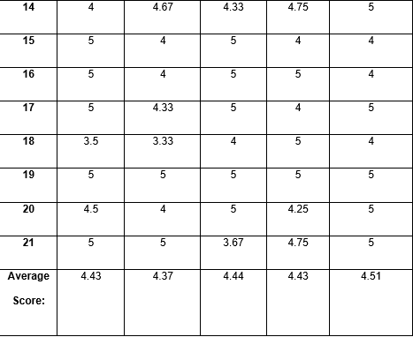

|  |  |
| --- | --- |
| **Overall Acceptability Rate** | **4.44** |
| **Descriptive Rating:** | **Acceptable** |

*Table 6: Testing and Evaluation Results*

The table above shows the average score and the descriptive rating evaluation results by the owner of the resort, ten (10) IT Professionals and other possible users. Tables above shows the gathered information where the result carried by the respondents using the scale of one (1) being the lowest or not acceptable and five (5) being the highest or highly acceptable. The average numerical of overall acceptability rate was 4.44 with the descriptive rating of Acceptable.

**Implementation Procedure**

This section includes the system installation and integration and user training plan. The proponents have to explain or demonstrate the system installation and integration in the company. They should also provide user training program plan for the company to fully adopt the system.

**System Installation and Integration**

After the completion of the developed system and performing the needed evaluation testing procedures, the proponents proceeded to the system installation and integration of all the system features. System Installation is about installing the system in the company and make running or usable for the people who would use the system. System integration is the process of linking variety of computing systems and software applications physically and functionally. The developed system will be installed in Bataan White Corals Resort. The company would provide the units that will be used by the admin. The proponents would assess the location for the system, arrange service installation, set-up hardware and software, and install the integrated system. After the system installation and integration, the proponents proceeded to the user training plan.

The proponents did the following activities for the installation and integration:

* Assess location for the system – the proponents checked the physical site and state for accessibility, availability and locality of service on where the system must be installed and integrated.
* Arrange service installation – the proponents verified if the services as electricity, communication, internet etc. are available.
* Setup hardware and software – the proponents built the hardware and install the software that the system needs.
* Install integrated system software – the proponents established the new system software was associated with all the subsystem securing that it would function simultaneously as a whole system.

**User-Training Plan**

To fully understand how the system works, how to navigate and how it functions, the proponents will provide a training and provide a user’s manual that will give the company fundamental instructions to follow and restrain human error. The proponents will also conduct hands on training and demonstrations on how to operate the system so it would give the employees more knowledge and to know the process and functions of the system.

**The training plans and activities are as follows:**

|  |  |  |
| --- | --- | --- |
| **Day** | **Training Plans** | **Facilities** |
| 1 | • Explain the significance of training program. • Explain some background and importance of our proposed system to the users. • Explain the purpose of Online Reservation and Billing System. • Answer the questions being lifted by the management. | Proponents |
| 2 | • Demonstrate the features, capacity or capabilities of the system. • Teach every module to the users. • Provide hands-on training under direct supervision. • Answer questions being raised by the users. | Proponents |
| 3 | • Persistent with the hands-on training until the users adapts the system. | Proponents |

*Table 7. Training Plans*

This table shows the training plans for the management together with the proponents to the Bataan White Corals Beach Resort in familiarizing the features and capabilities of the Online Reservation ang Billing System for Bataan White Corals Beach Resort over a period.